Microsoft Cloud for Healthcare in a Day

Lab 04: Azure Health Bot

Step-by-Step Lab

90 minutes

April 2022

Contents

Overview 3

Learning Objectives 3

Prerequisites 3

Azure Health Bot 3

Industry Prioritized Scenarios 4

Healthcare Story 4

Exercise 1: Set Up Azure Health Bot 5

Task 1: Install Azure Health Bot in Azure Subscription 5

Task 2: Update Azure Health Bot Settings to Enable Dynamics 365 Integration 9

Task 3: Obtain Azure Application ID 13

Exercise 2: Configure Omnichannel Live Chat 15

Task 1: Assign Omnichannel Agent Security Role 15

Task 2: Create Health Bot User in Dynamics 365 Customer Service 19

Task 3: Create and Configure Human Agent Queue 25

Task 4: Create Workstream with Context Variables and Routing Rules 28

Exercise 3: Embed Health Bot in Power Apps Portal 40

Exercise 4: Extend Azure Health Bot with Custom Scenarios 43

Task 1: Create MCH_PatientService Scenario 44

Task 2: Create MCH_PatientServiceWelcome Scenario 60

Task 3: Configure Welcome Scenario as Automatic 64

Task 4: Test Health Bot Escalation from Power Apps Portal to Dynamics 365 Omnichannel 65

Summary 69

Overview

Learning Objectives

In this lab, you will learn to do the following:

* Set up Azure Health Bot
* Configure Dynamics 365 Customer Service Omnichannel Live Chat
* Embed Azure Health Bot in a Power Apps Portal
* Extend Azure Health Bot with custom scenarios

Prerequisites

* None

Azure Health Bot

The Azure Health Bot Service is a cloud platform that empowers developers in healthcare organizations to build and deploy their compliant, AI-powered virtual health assistants and health bots, that help them improve processes and reduce costs. It allows you to offer your users intelligent and personalized access to health-related information and interactions through a natural conversation experience.

Using the service, healthcare organizations can build a "health bot instance" and integrate it with their systems that patients, nurses, doctors, and other representatives interact with. Building an instance allows you to:

* Improve processes
* Improve services
* Improve outcomes
* Reduces cost

The Health Bot Service contains a **built-in medical database**, including **triage protocols**. You can also extend a health bot instance to include your own scenarios and integrate with other IT systems and data sources. To learn more about Azure Health Bot, you can reference this Microsoft Docs article: [Azure Health Bot Overview](https://docs.microsoft.com/en-us/azure/health-bot/).

Industry Prioritized Scenarios

The Azure Health Bot focuses on the **Enhance patient engagement** priority scenario by creating a virtual bot health option to allow for new avenues of care with embedded insights.

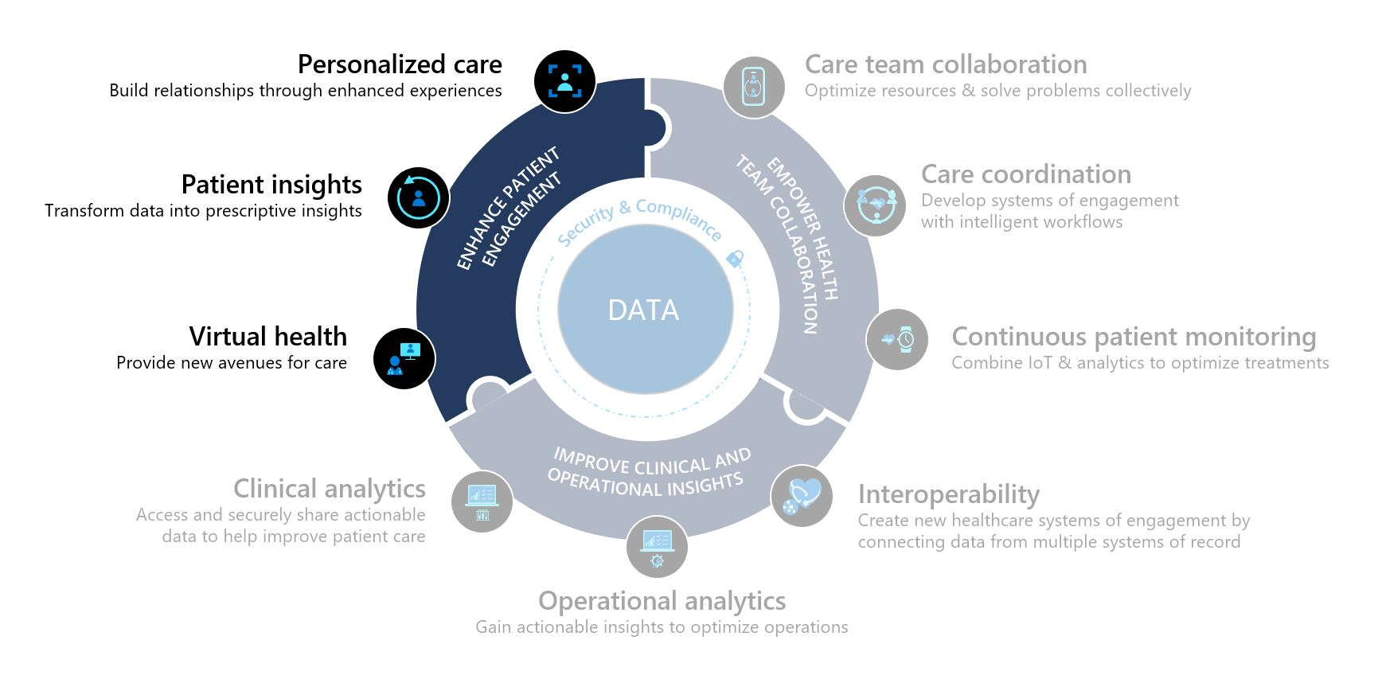

Healthcare Story

This lab will focus on Lamna Healthcare Company.

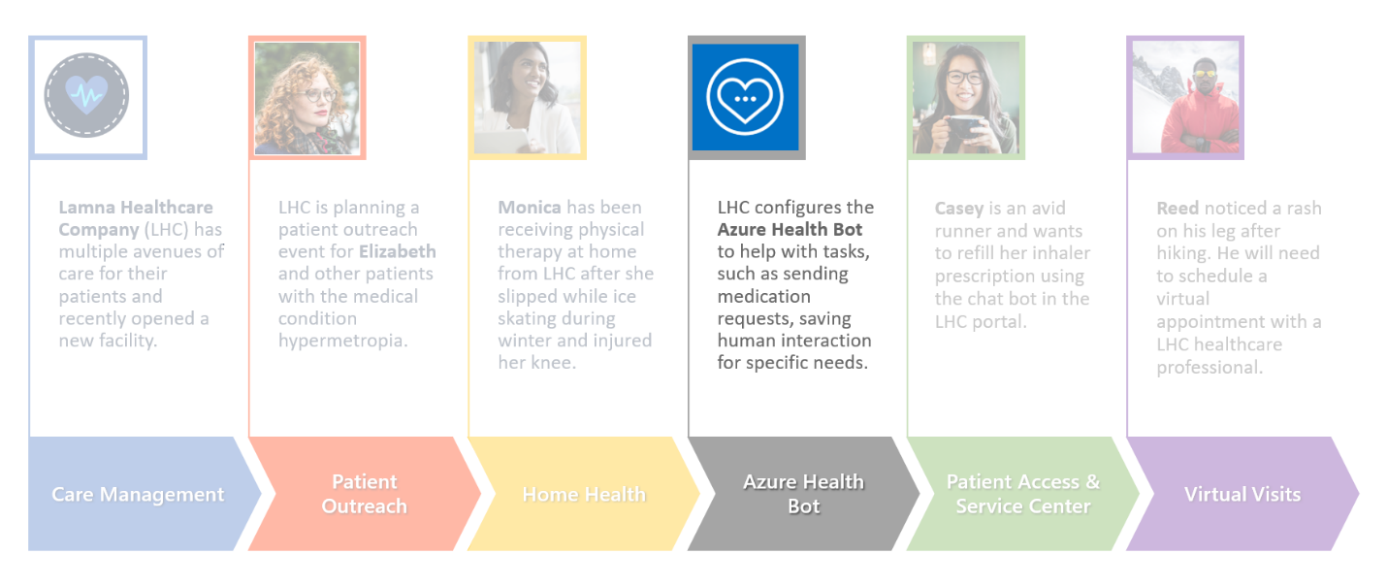

As part of their digital transformation efforts, Lamna Healthcare Company is seeking to streamline their patient engagement capabilities by implementing Azure Health Bot to help improve processes and services, including receiving medication requests. By allowing patients to interact with this service, Lamna Healthcare Company will move one step closer to their goal of improving patient outcomes while reducing overall costs.

In this lab, you will play the role of a Lamna Healthcare IT developer and configure Azure Health Bot for a medication refill scenario.

Exercise 1: Set Up Azure Health Bot

In this exercise, you will do the following:

* Set up Health Bot from Azure Portal
* Configure and enable the integration between Dynamics 365 Omnichannel and Health Bot
* Configure and enable Bot channel to obtain a Bot Id

**Azure Health Bot** empowers developers in healthcare organizations to build and deploy AI-powered, compliant, conversational healthcare experiences at scale. It combines built-in medical database with natural language capabilities to understand clinical terminology and can be easily customized to support your organization's clinical use cases. The service ensures alignment with industry compliance requirements and is privacy protected to HIPAA standards. To learn more about Azure Health Bot, please reference this [Azure Health Bot documentation](https://docs.microsoft.com/en-us/azure/health-bot/).

Task 1: Install Azure Health Bot in Azure Subscription

1. While logged in to your Microsoft 365 tenant, open a new tab in your internet browser incognito or in-private mode and navigate to Azure Portal at <https://portal.azure.com/>
2. Search for **Azure Health Bot** in the top search barand **select** it from the search results.

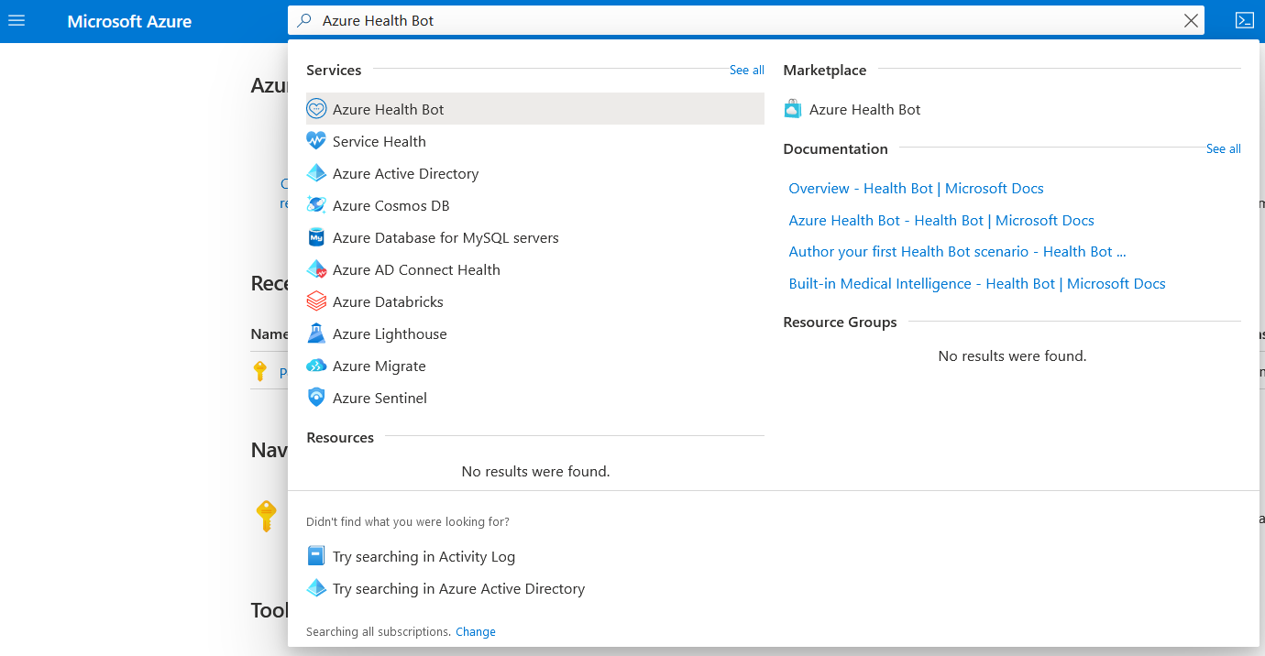

1. Click **Create** button to create a new Azure Health Bot instance.

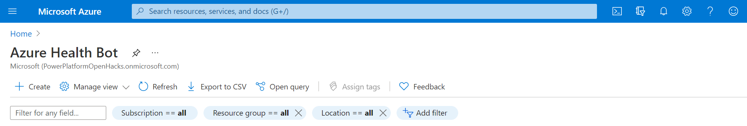

1. You will be redirected to the Azure Health Bot page. Enter the following information:



* 1. **Subscription**: PowerPlatformOpenHacks Subscription
  2. **Resource Group**: IndustryLabs
  3. **Name**: iaduser[x]-healthbot (e.g., iaduser01-healthbot, using your assigned user)
  4. **Region**: East US
  5. **Plan**: Free (F0)

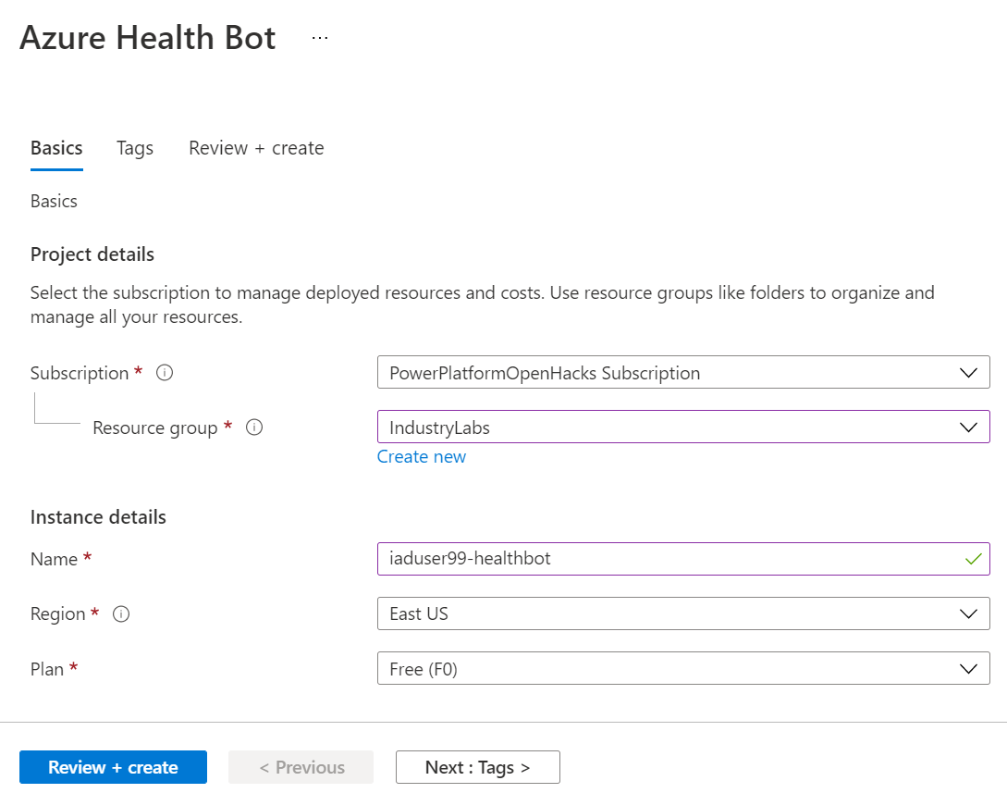

1. Select **Review + Create**.
2. On the Review and create page, verify your details are correct as Azure validates your Health Bot. After validation passes, the create button will become enabled. Click **Create**.

*Note: It will take few seconds to run the backend process before the Create button is enabled.*

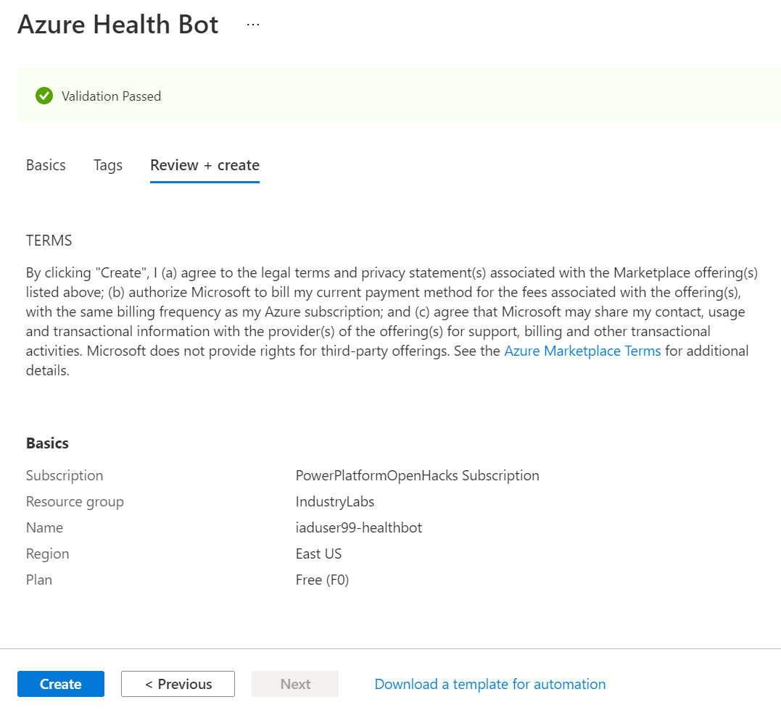



1. You will be redirected to the **Deployment** pagefor your new Azure Health Bot.

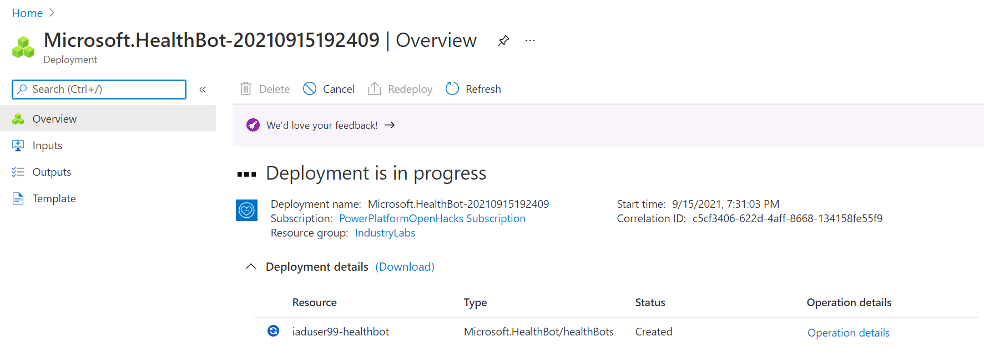

1. When deployment is complete, the **Go to resource** button will enable. Please wait until deployment is complete for the Azure Health Bot, then select **Go to resource** when enabled.

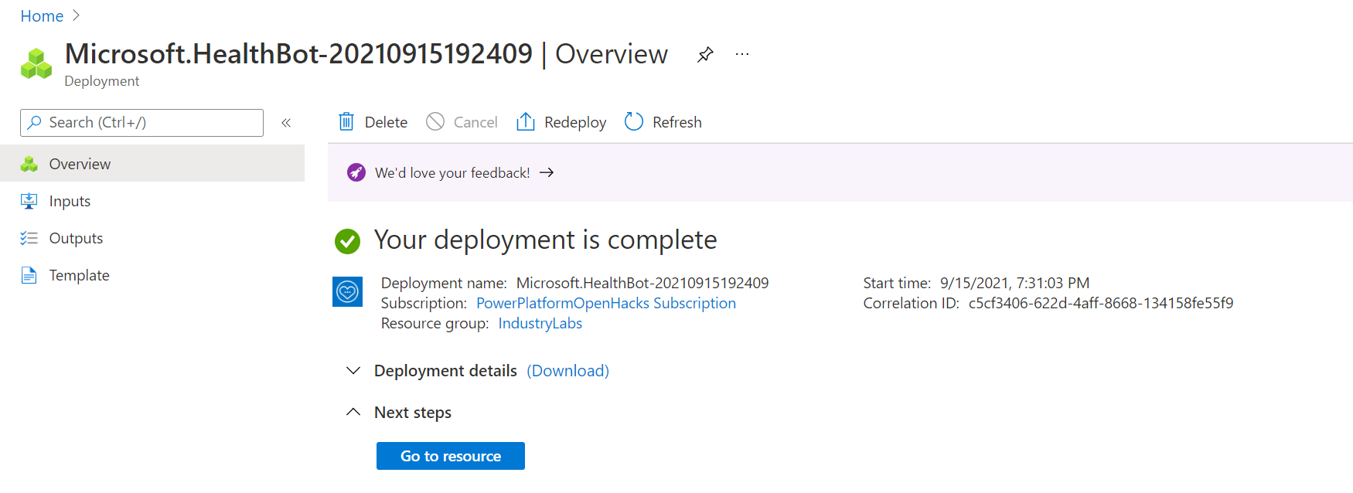

1. You will be redirected to the **Resource** page for your new Azure Health Bot. Click the **Management portal** link in the Essential section to open your Azure Health Bot instance configuration page.

*Note: Please copy this Management portal link and store it to access the Health Bot later.*

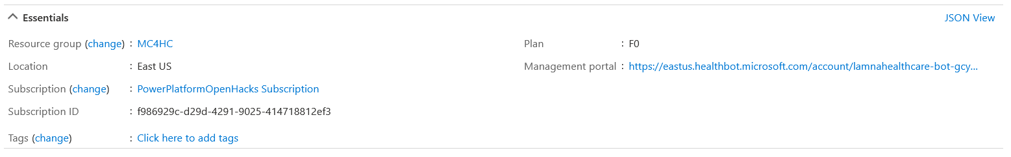



1. You will be navigated to your new Azure Health Bot instance homepage.

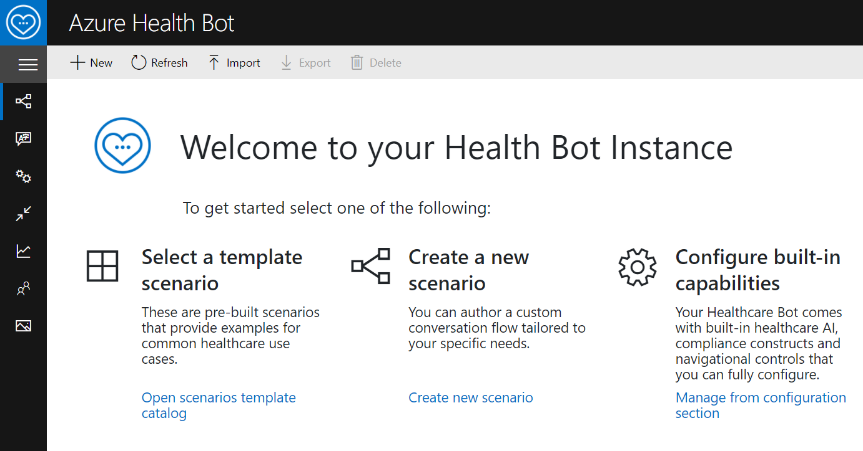

**Congratulations!** You have successfully created a new Health Bot instance in your Azure tenant.

Task 2: Update Azure Health Bot Settings to Enable Dynamics 365 Integration

1. On the Azure Health Bot homepage, **expand** the side navigation bar to see the sitemap labels.

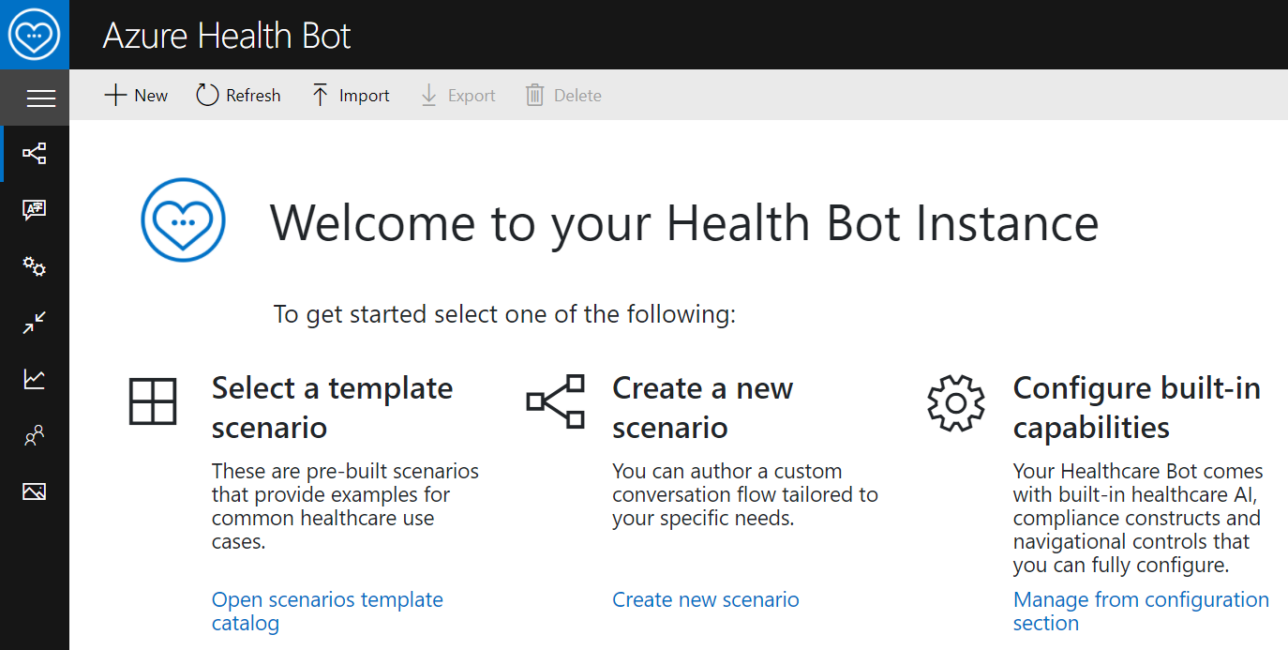

After expanding, you will see the sitemap labels next to the icons.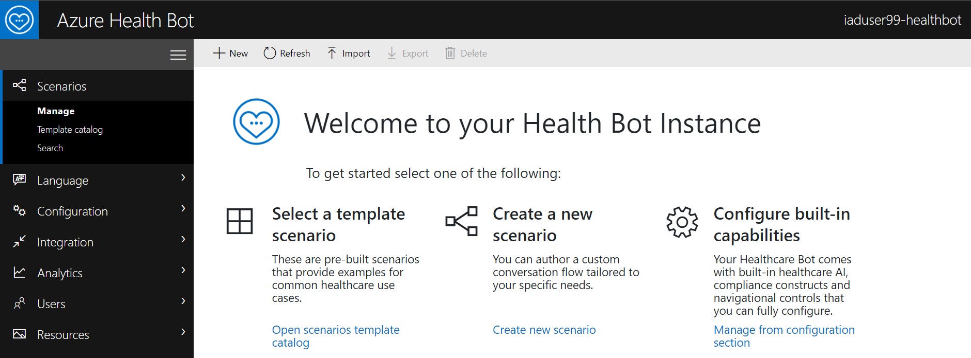

1. Select **Configuration** > **Conversation** on the navigation bar.

.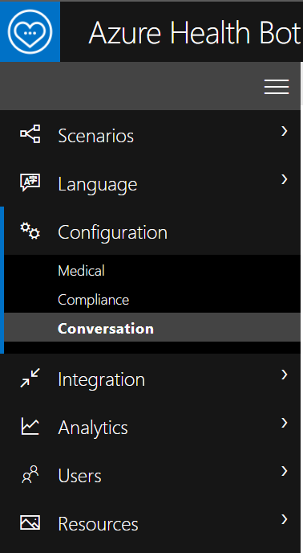

1. You will be landed in the **Interactions** tab.

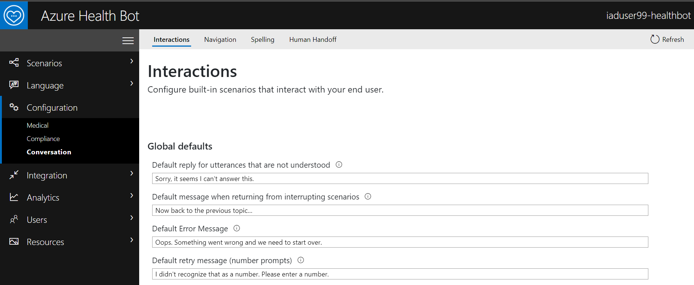

1. Select **Human Handoff** tab in the Conversation settings.

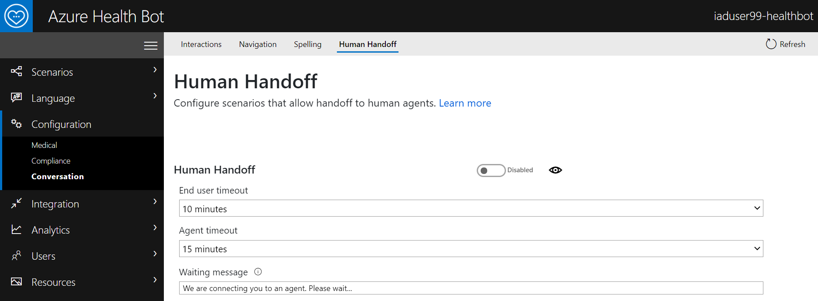

1. Scroll to the bottom of the **Human Handoff** page. Under **Dynamics 365 Omnichannel**, toggle **Enabled** for **Bridge Messages**.This is required to allow communication and bridge messages between the Azure health Bot and Dynamics 365 Omnichannel for Customer Service.

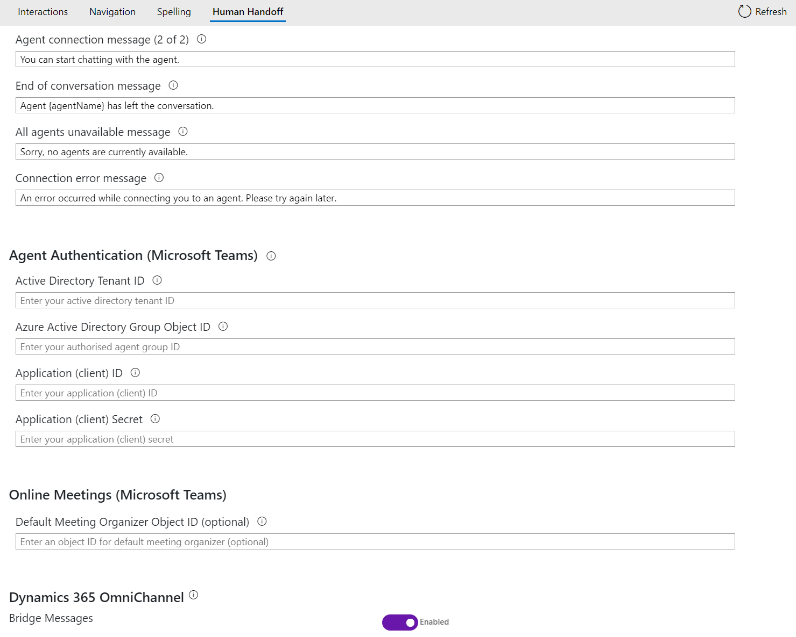

1. Click **Save** in the top right.

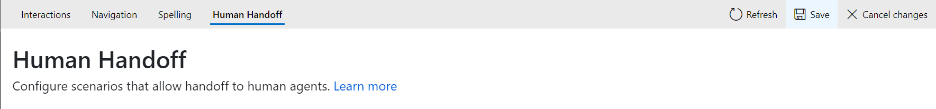

1. Now let’s enable the Health Bot for **Microsoft Teams** Channel.
2. Navigate to **Integration** > **Channels.**

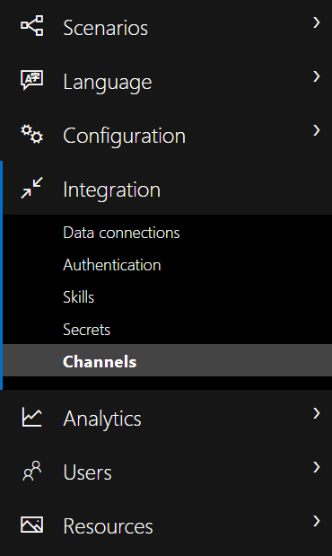

1. In the Channels list, select the toggle to **enable Microsoft Teams.**

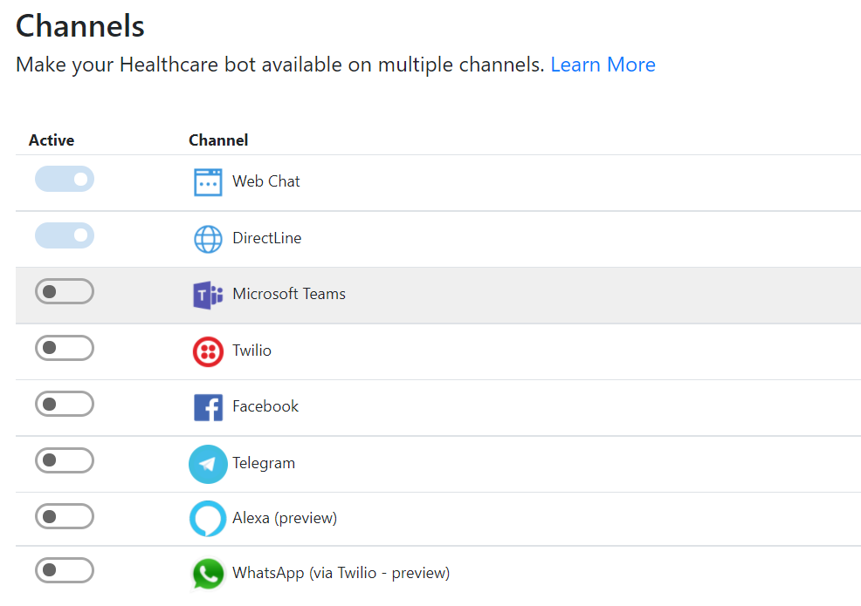

1. This will bring out a side window with your **Bot Id** information. **Copy and store** the BotId for later to use when creating the Dynamics 365 Application User.

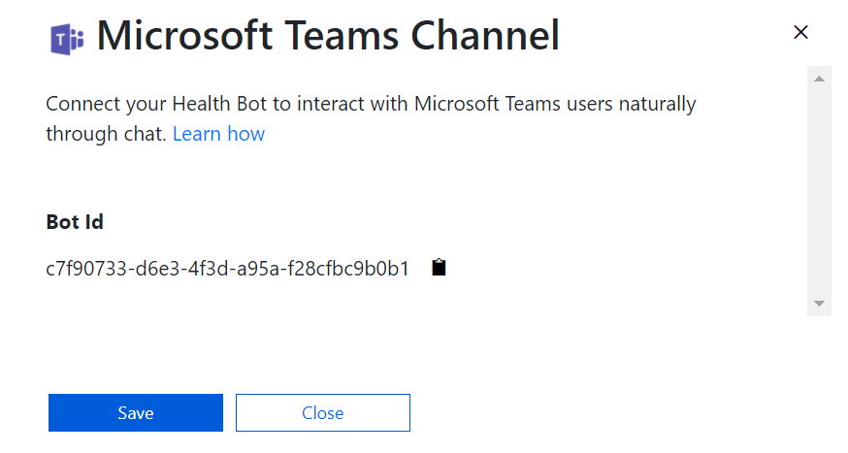

1. Select **Save**. This should enable Teams channel and your Microsoft Teams toggle should reflect accordingly.

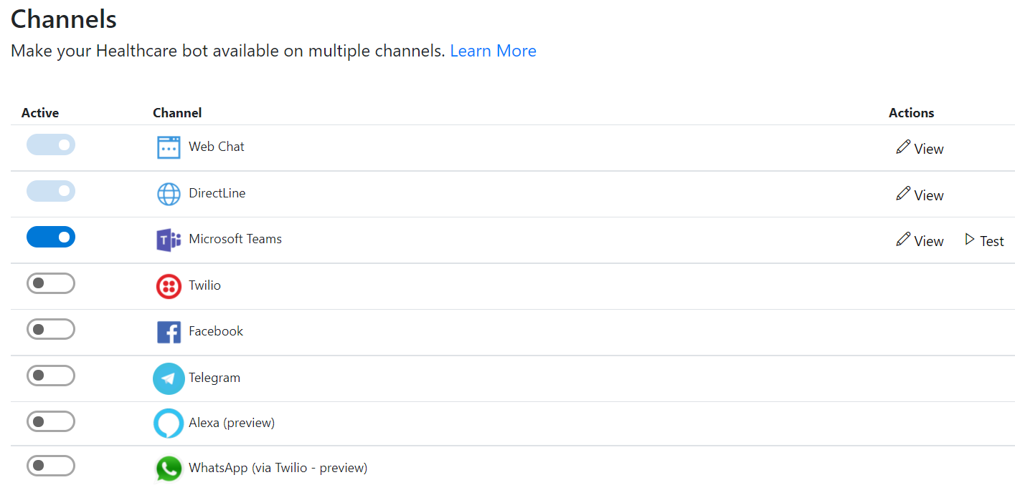

**Congratulations!** You completed the Azure Health Bot settings for integration with Microsoft Teams and Dynamics 365 Omnichannel for Customer Service.

Task 3: Obtain Azure Application ID

In this task, you will be using an Azure Application ID already created in our Azure tenant called “**MCH Application Id**”. Registering this Id establishes a trusted relationship between your Dynamics 365 app and the Microsoft identity platform. Using this Id, you will later create a Dynamics 365 Application User to bridge the authentication between Azure Health Bot and Power Apps.

1. Navigate back to the Azure Portal and search for **App Registrations** in the Search box.

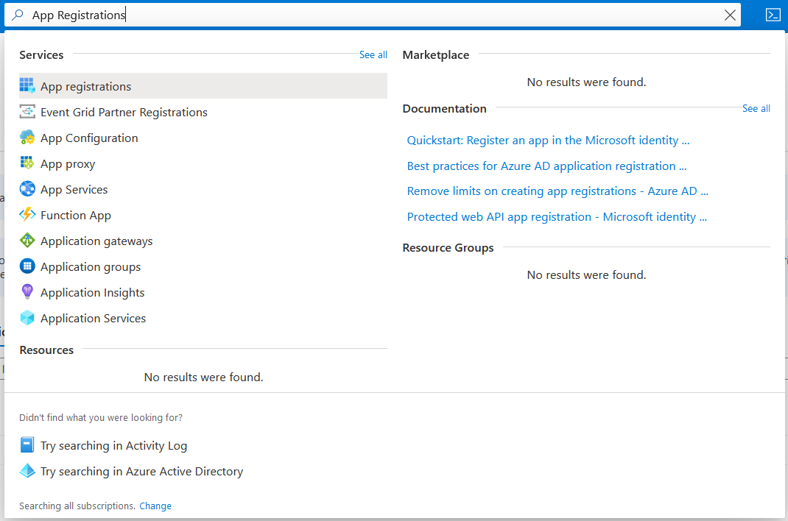

1. You will be landed in the App registration homepage on the Owned applications tab.

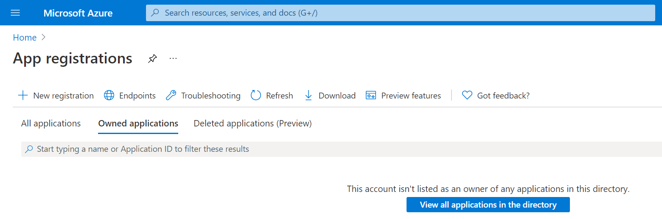

1. Select the **All applications** tab.

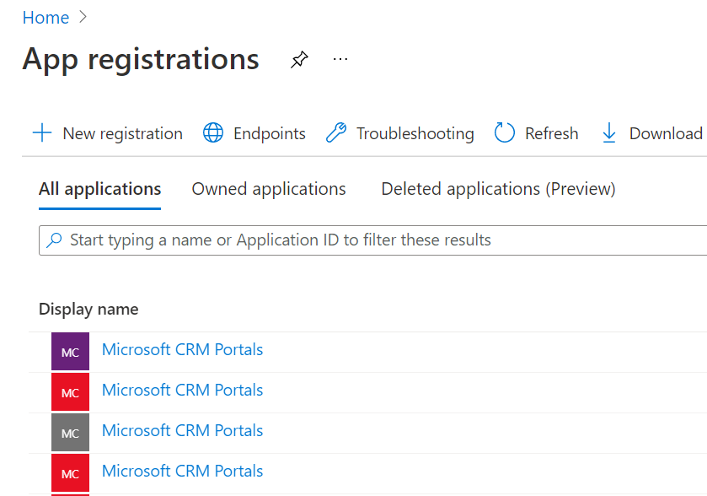

1. To **search** for our Application Id, type “**MCH Application Id**” in the Search box.

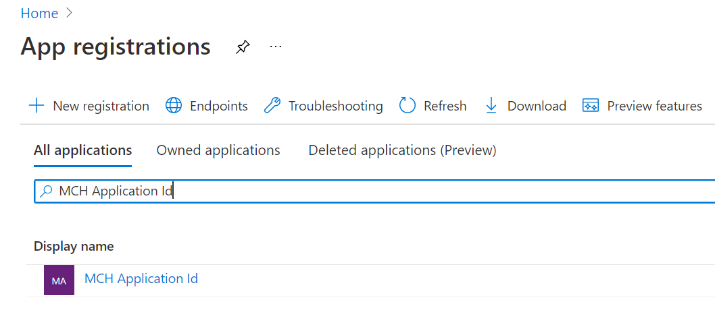

1. Select the **MCH Application Id** app registration resource. **Copy and store** the **Application (client) ID** for later to use when creating the Dynamics 365 Application User.

*Note: ID values have been removed in the screenshot for privacy purposes.*

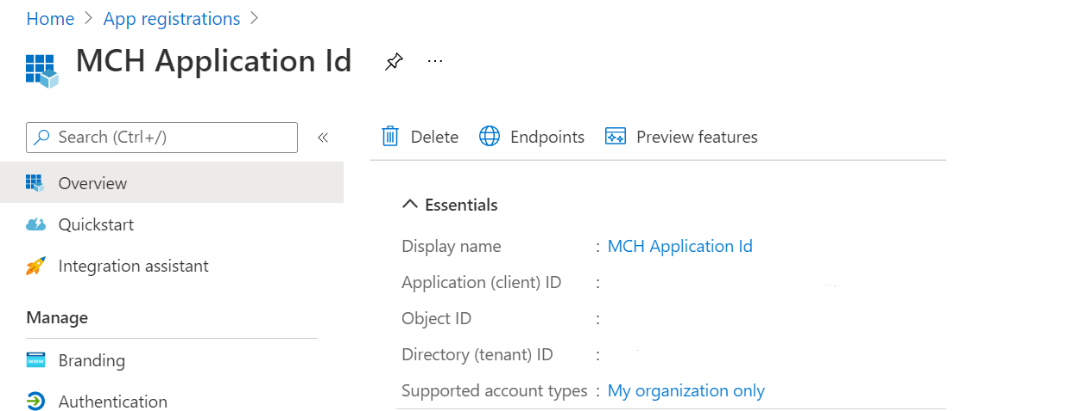

**Congratulations!** You have successfully obtained the MCH Application ID from Application Registrations in the Azure Portal.

Exercise 2: Configure Omnichannel Live Chat

In this exercise, you will be configuring live chat for **Dynamics 365 Omnichannel for Customer Service**. Omnichannel for Customer Service offers a suite of capabilities that extend the power of Dynamics 365 Customer Service Enterprise to enable organizations to instantly connect and engage with their customers across digital messaging channels.

In the following tasks, you will complete the following:

1. Assign Omnichannel Agent security role to your user
2. Create an Application User using the **MCH Application Id** and your **Bot Id**
3. Configure Queues and Workstreams for bot and agent users
4. Configure a Context Variable and Routing rule to route the message either to a Bot or Agent.

Task 1: Assign Omnichannel Agent Security Role

1. While in the In-Private or Incognito window, navigate to [Power Apps](https://make.powerapps.com/).
2. Ensure the correct environment from the upper right **Environment** drop down is selected. 
3. Select the **gauge icon** in the upper right corner and navigate to **Advanced Settings**.

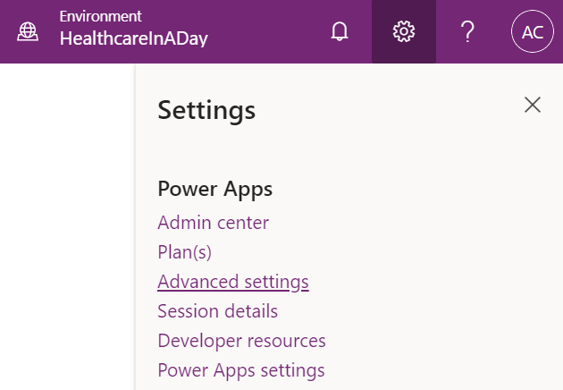

1. A new window should open and navigate to Dynamics 365. It may take a while to load. If it’s been longer than a minute, stop and reload the page. It should then load faster. It will land you in the Business Management section of Dynamics 365.

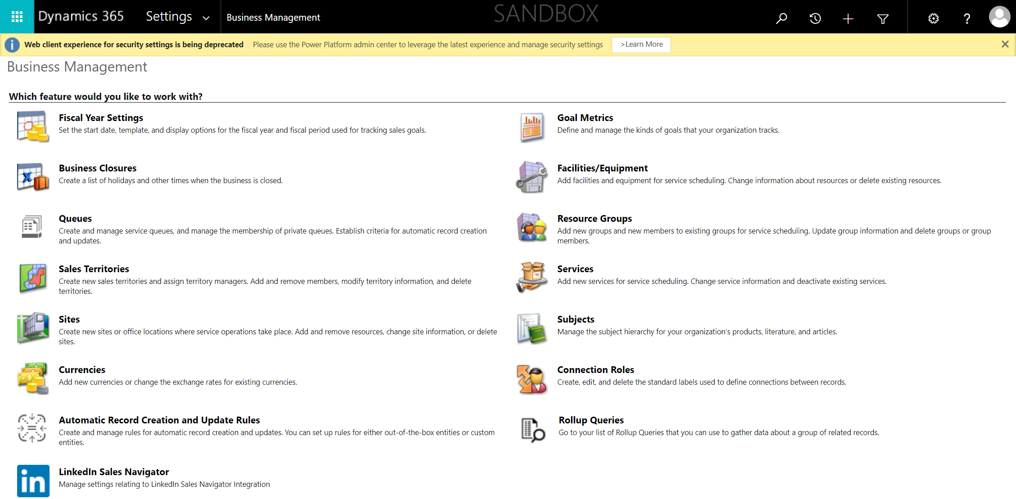

1. On the top command bar next to Dynamics 365, select **Settings** to open the drop-down, then select **Security** in the third columnunder System.

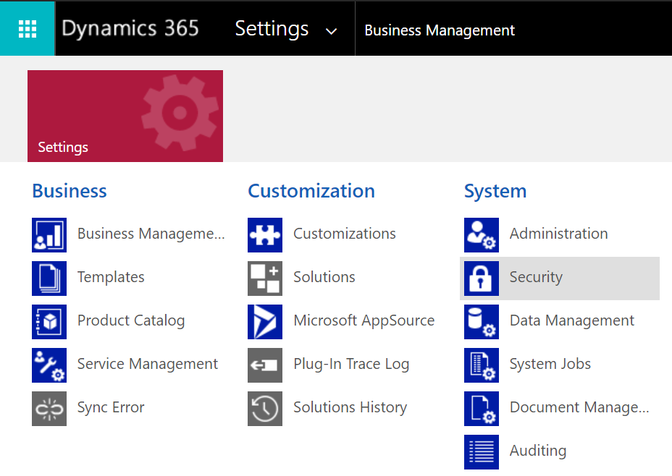

1. Under Security, select **Users**.

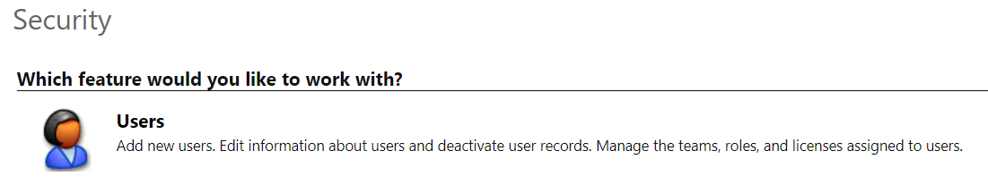

1. Switch the view drop down from Omnichannel Users to **Enabled Users** for the grid view so that your user will show in the list.

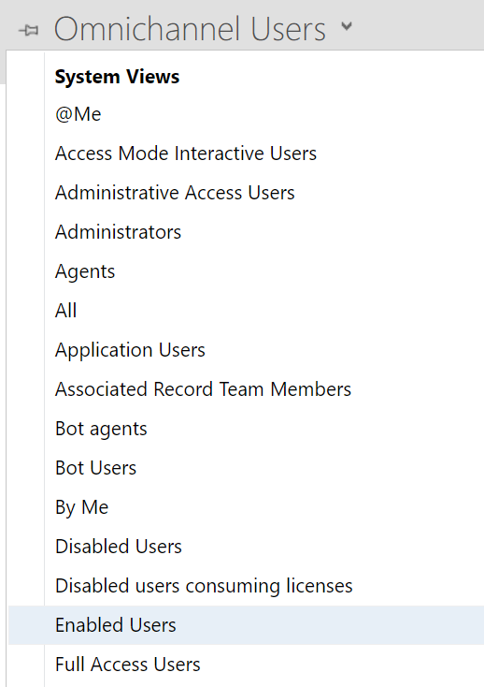

1. While in the Enabled User list, scroll to **find your user** or use the **Search** bar.

*Note: If you are in an official training, search for you assigned user – IAD User [x]*

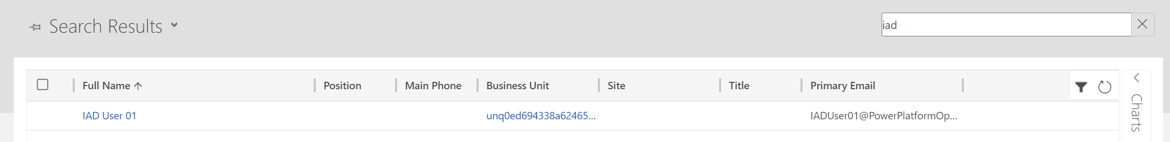

1. Select your user for the training and select **Manage Roles** on the top command bar.

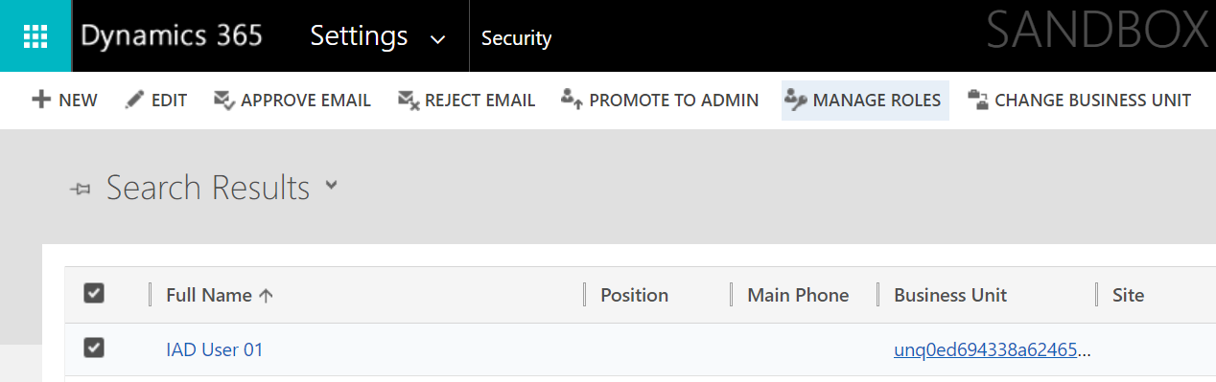

1. Select the Omnichannel Agent roles to assign to your user and select **OK**.

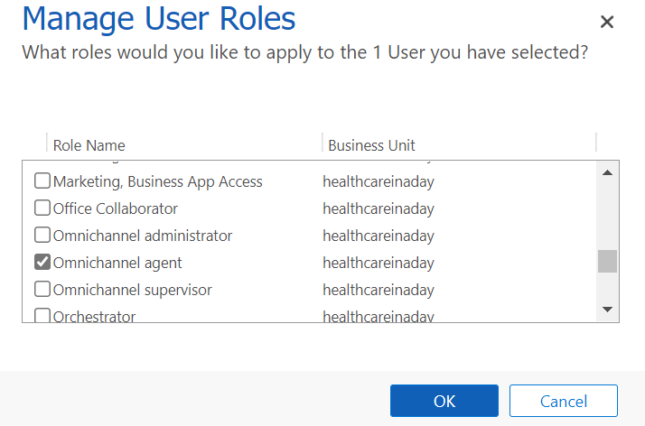

**Congratulations!** You assigned the proper omnichannel agent role to your user to allow you to be a live agent in omnichannel.

Task 2: Create Health Bot User in Dynamics 365 Customer Service

We need two users to configure in Omnichannel for Dynamics 365 Customer Service:

* **Health Bot User** – This is the Azure Health Bot user we created in the previous exercise.
* **Omnichannel Agent** **User** – This is your current user whom you are logged into Dynamics 365. This will allow you to be a live agent in Customer Service who receives messages from portal users through Azure Bot escalations*. Note: For official trainings, this is your assigned user, iaduser[x]*

In this task, you will create a **Bot User** which helps connect **Azure Health Bot** with **Omnichannel live Chat**.

1. Go to <https://admin.powerplatform.microsoft.com/>.
2. Select your Microsoft Cloud for Healthcare environment from the list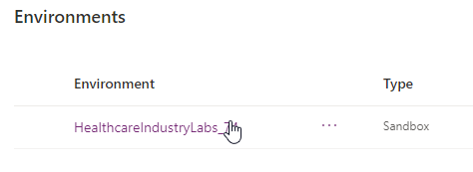
3. You will land on your environments detail page.

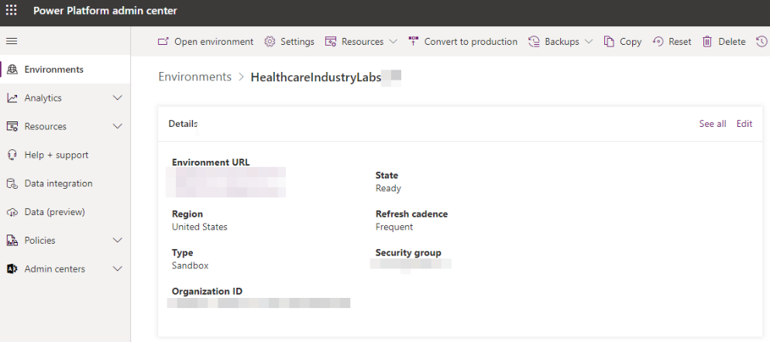

1. Click the **Settings** button on the top command bar.

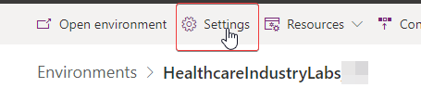

1. Expand **Users + permissions** and click **Application users**. 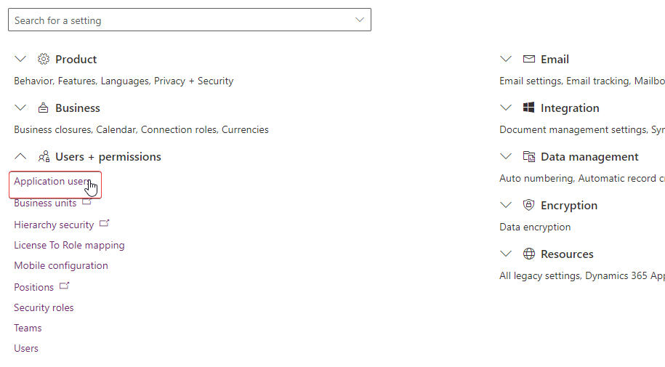
2. Select (**+**) **New app user** button to create a new Application User.

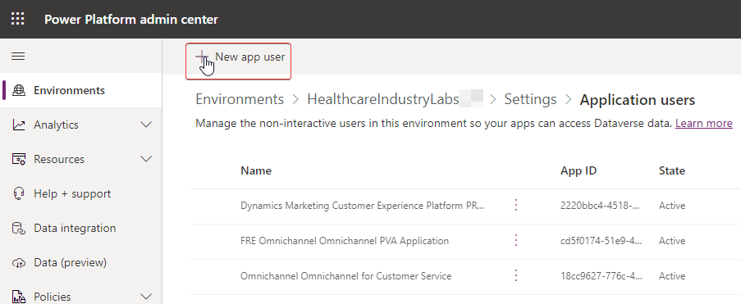

1. Select (+) **Add an app** on the create screen that slides out on the right side. 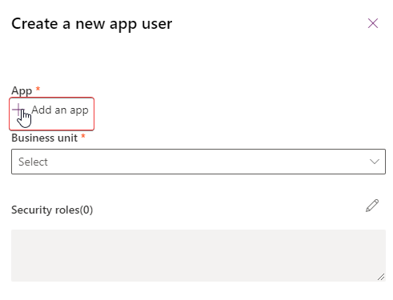
2. Paste the **Application ID** (the Application (client) ID you obtained in the Azure portal for the supplied MCH Application ID) into the search box and select the app from the list. Click **Add** at the bottom right. 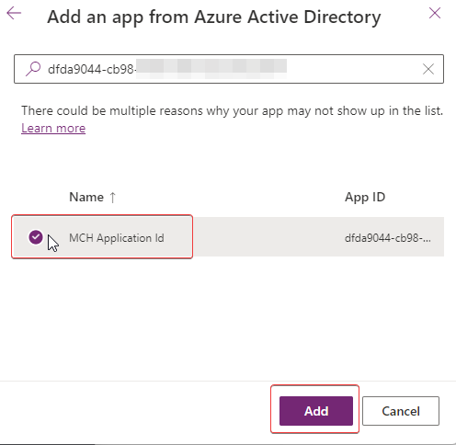
3. Select a **Business unit** from the drop-down list (the options in the list will be unique for each Dynamics 365 environment). Click **Create** at the bottom right. 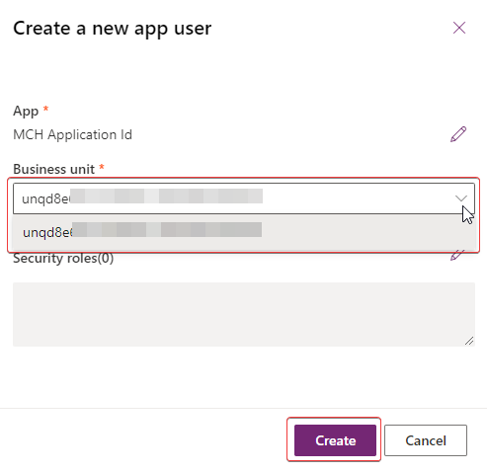
4. Return to the Dynamics 365 User page, switch the view to **Enabled Users**.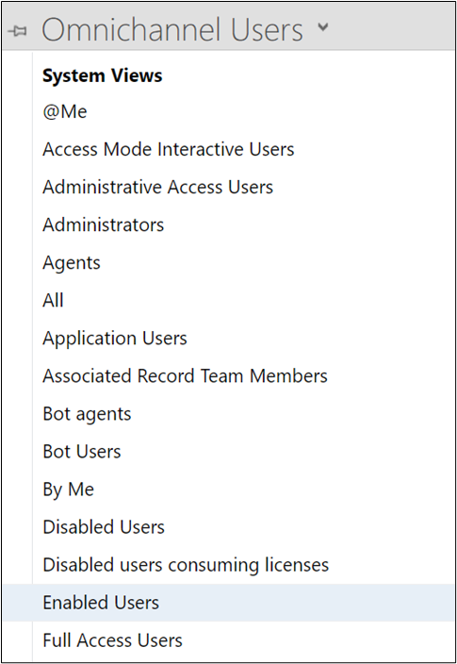
5. While in the Enabled User list, scroll to **find your App user** or use the **Search** bar. Double click on the user or select the row and click Edit.

*Note: If you are in an official training, search for the Application User – MCH Application ID*



1. Change the **form type** from User to **Application User** above the User Name.

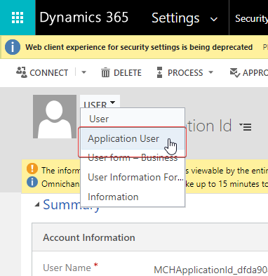

1. You will see a new form appear that aligns to an Application User.

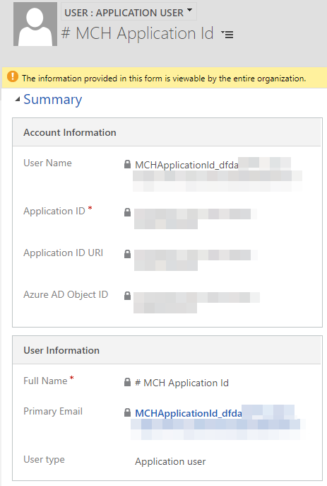

1. In the **User Information** section, enter or select the following information and click the **Save** icon in the bottom right corner:
   1. **User type**: Select **Bot application user**. This will *display a new field* to store the Bot application Id.
   2. **Bot application ID**: This is the Azure Health BotId you copied when enabling the Teams channel. This field is displayed once the User Type is selected to be Bot application user.

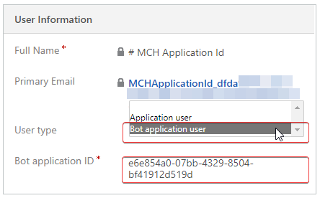

1. Select **Manage Roles** on the command bar.

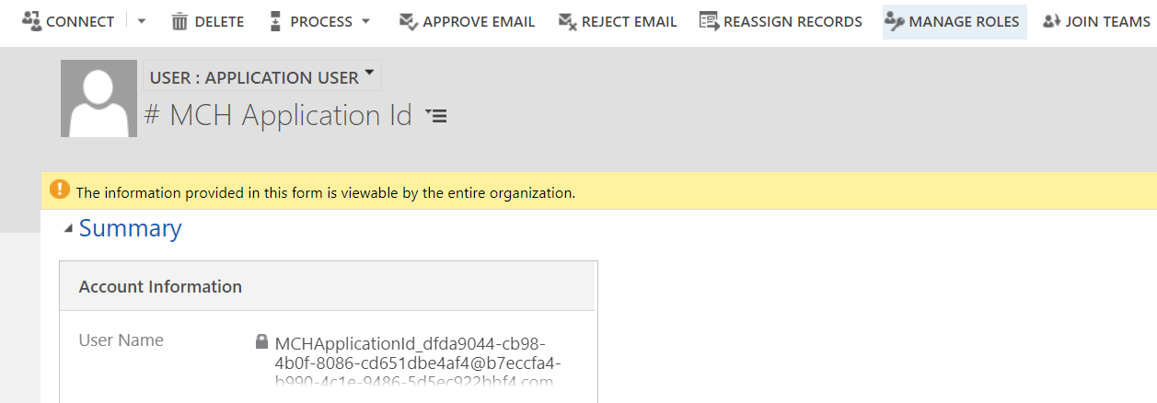

1. Assign the **Omnichannel Agent** **role** to the Bot User as you did for your own user in the previous task. This will allow the bot to act as an omnichannel agent like your user.



**Congratulations**! You successfully created a Bot User and assigned to it the Omnichannel Agent role.

Task 3: Create and Configure Human Agent Queue

Queues are used to collect and distribute workload among agents. Agents are added as members to the queues and the workload is distributed among the agents based on assignment methods. Learn more at [Manage queues for unified routing](https://docs.microsoft.com/en-us/dynamics365/customer-service/queues-omnichannel?tabs=customerserviceadmincenter).

In this task, you will create the omnichannel queue necessary to communicate with a human agent.

1. In <http://make.powerapps.com>, open the **Omnichannel admin center** app.

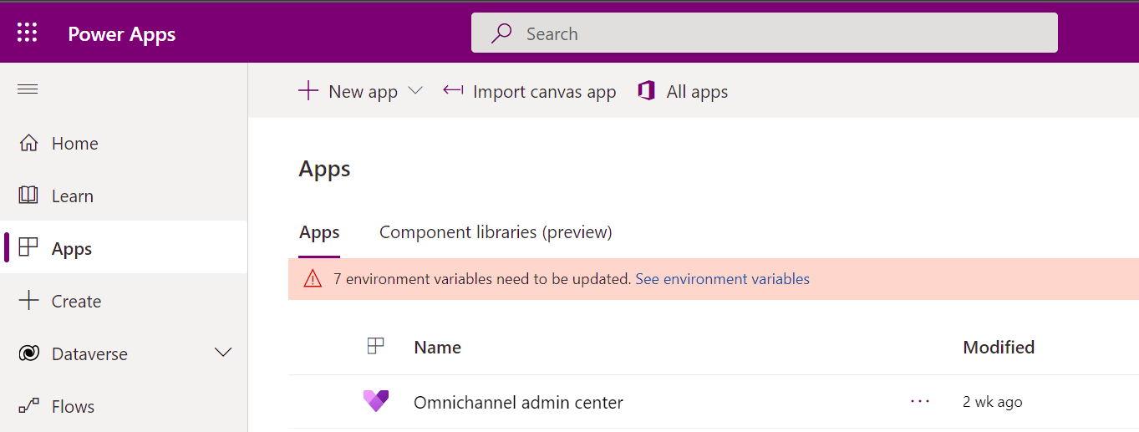

1. You should be landed on the **Homepage**. Select **Create a queue** from the center shortcut.

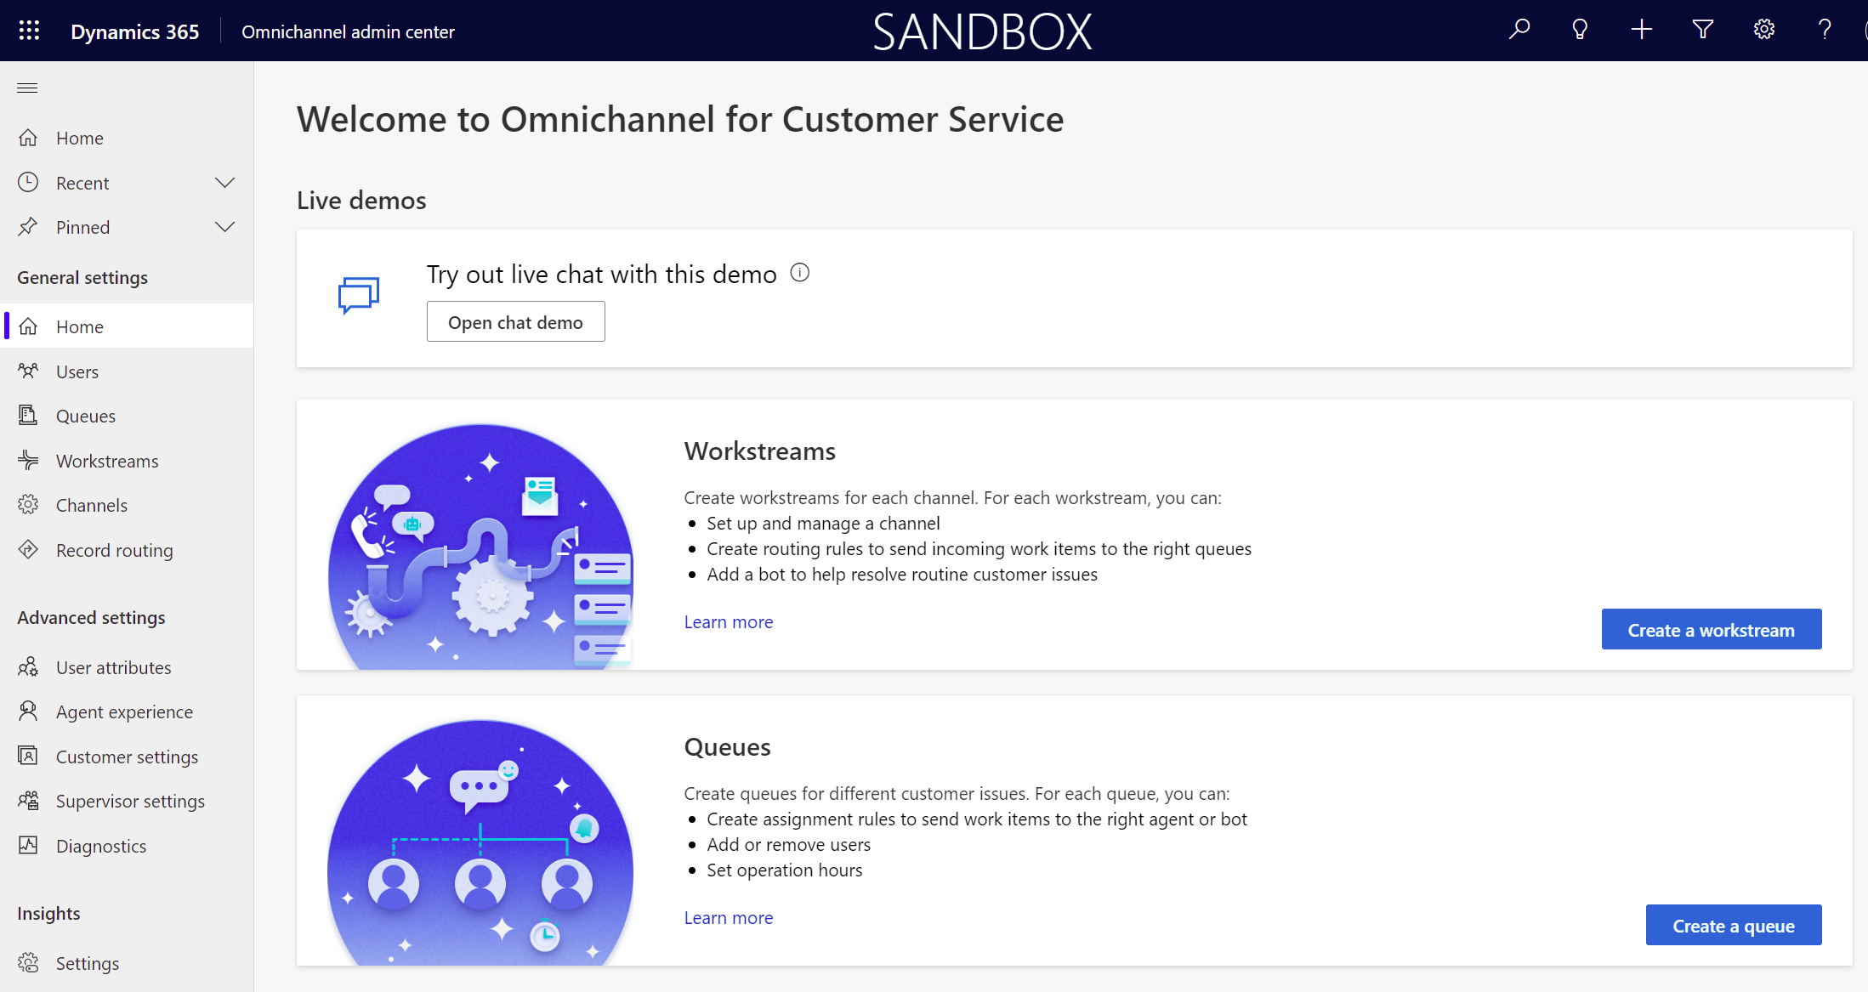

1. You will now create a queue called “**Escalate to Human**” which will manage and redirect the incoming messages from a user to a Customer Service (human) Agent when Bot sends the user through to a live agent. Create the new Queue with the following details:
   1. **Name**: Escalate to Human
   2. **Type:** Messaging
   3. **Group number**: [any number]
   4. Click **Create**.

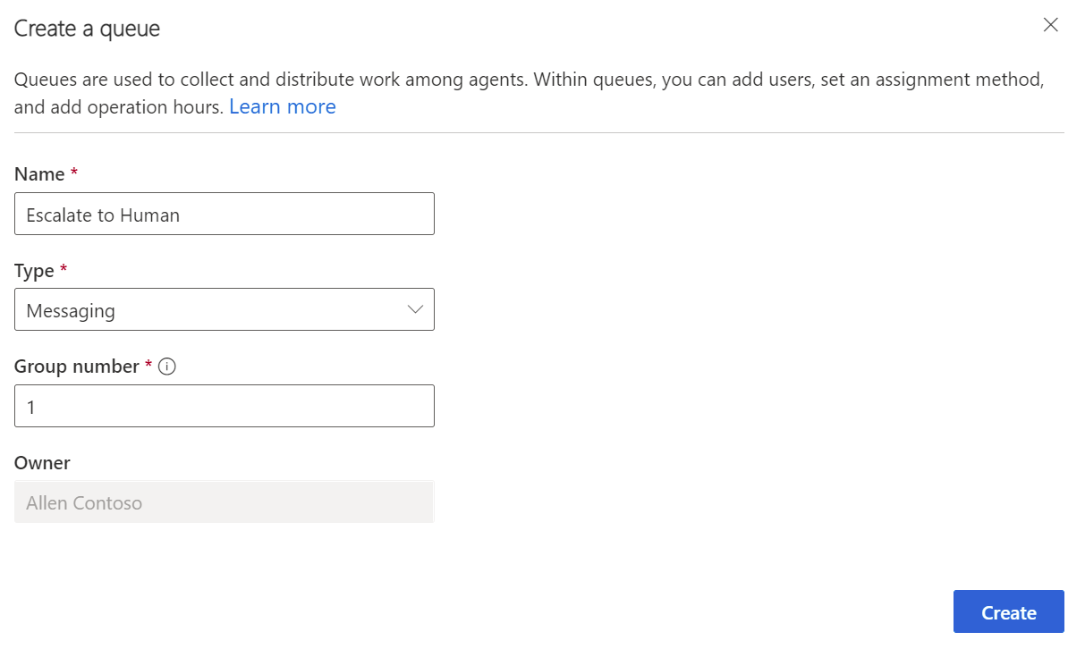

1. The new Queue record will open and contain a “Users” **subgrid**. Select **Add users** in the subgrid.

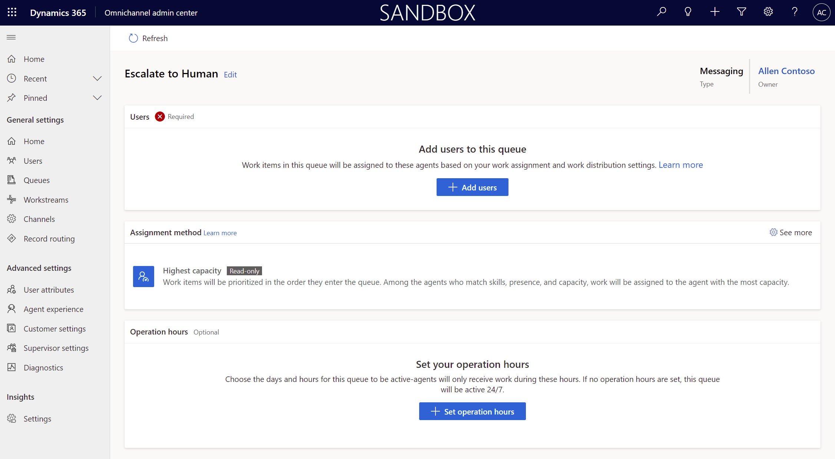

1. **Search** **for your user** and **add** it to the queue.

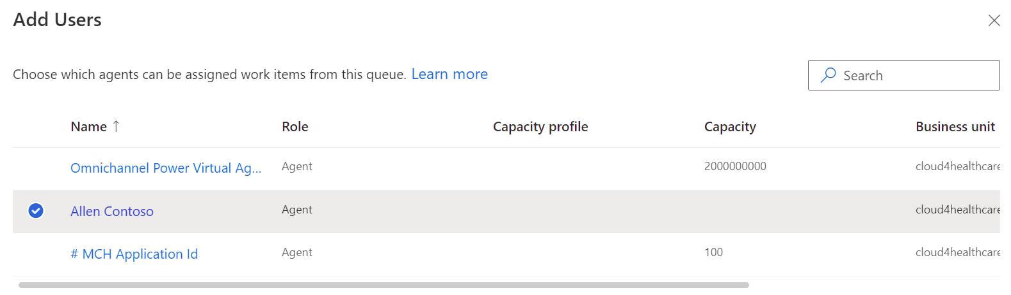

1. The user is now added to the queue with the **agent** role**.**

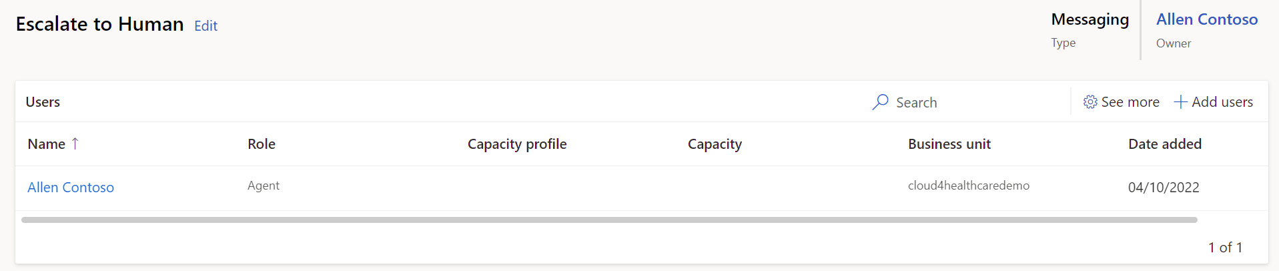

1. Select **Queues** on the left navigation bar and you will now see it listed in the queues subgrid.

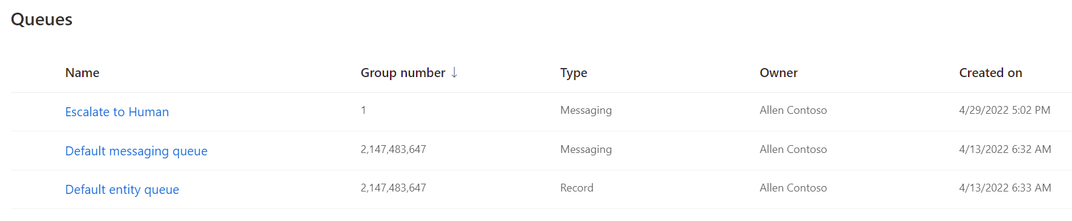

**Congratulations!** You have created the necessary queue to escalate to human agent and added your user to the messaging queue. Now we can create the workstream to initially route to a virtual bot along with routing rules to direct the user to Escalate to Human queue in the proper conditions.

Task 4: Create Workstream with Context Variables and Routing Rules

Workstreams are containers to enrich, route, and assign work items. A workstream is associated with a channel, such as live chat, voice, or case. After a bot is added to a workstream, the incoming work item is first routed to the selected bot at runtime based off classification rules. Learn more at [Create workstreams for unified routing](https://docs.microsoft.com/en-us/dynamics365/customer-service/create-workstreams?tabs=customerserviceadmincenter).

In this task, we will set up basic chat routing with a new workstream. This will allow for users to chat with a bot user initially and route to a live human agent in the proper situation. We will complete the following:

* **Create a new workstream**
* **Set up a live chat channel**
* **Add bot for initial routing**: Initial customer conversation is directed to the Azure Health Bot
* **Create context variable and routing rule to escalate to human agent**: When context variable **EscalateToAgent** is present and set to 1, we route to the “Escalate to Human” queue we previously set up with our user as an agent who can take over the conversation.

1. Navigate to **Workstreams** on the left navigation bar.

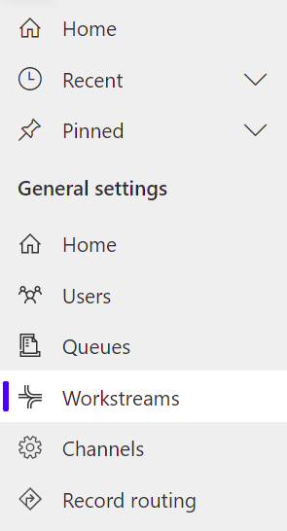

1. Select **+ New Workstream** on the command bar.

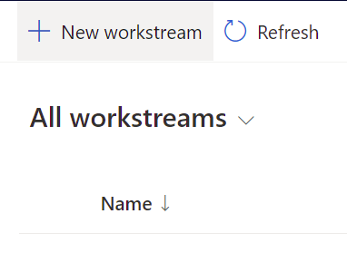

1. Enter the following details for the new workstream:
   1. **Name**: Chat Workstream
   2. **Type** : Messaging
   3. **Channel**: Chat
   4. **Work distribution mode**: Push
   5. Select **Create**

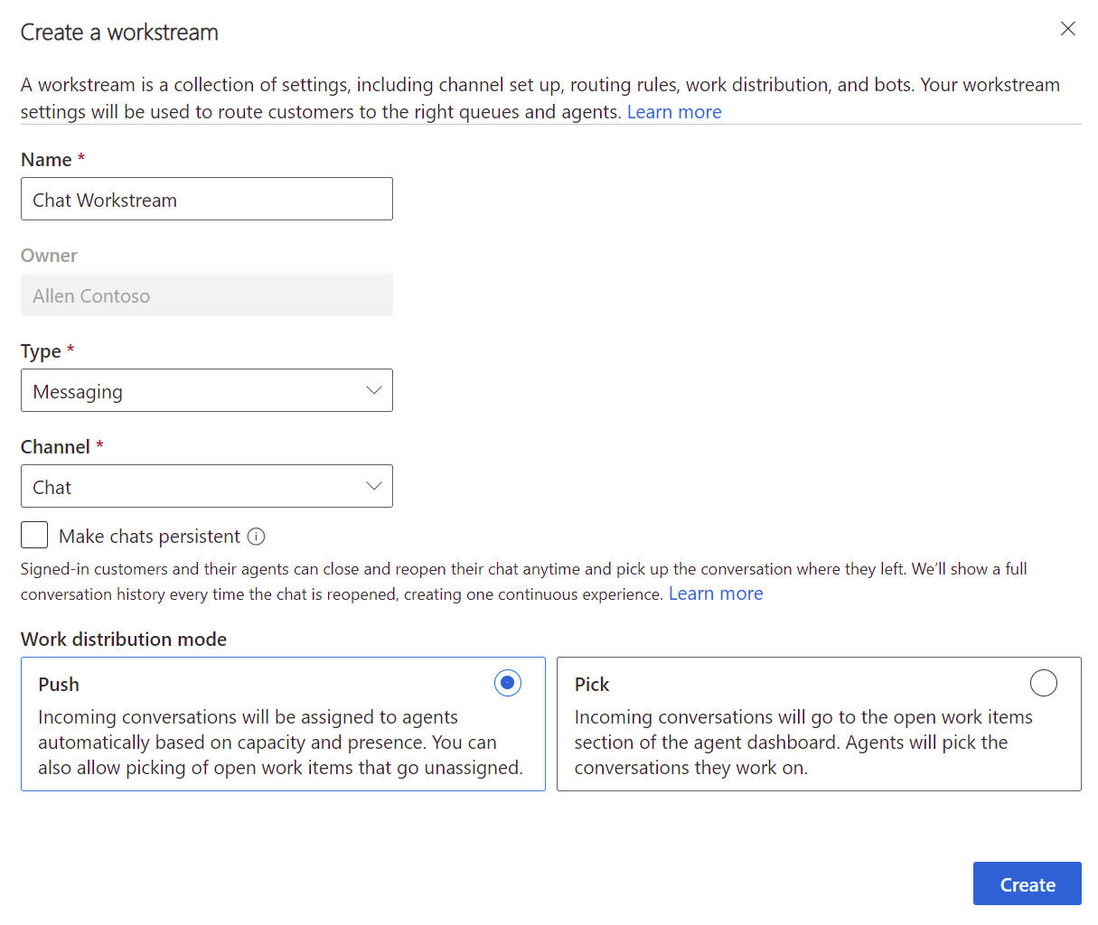

1. On the Chat Workstream record, you must set up your chat channel. Select **Set up chat** under Live chat.

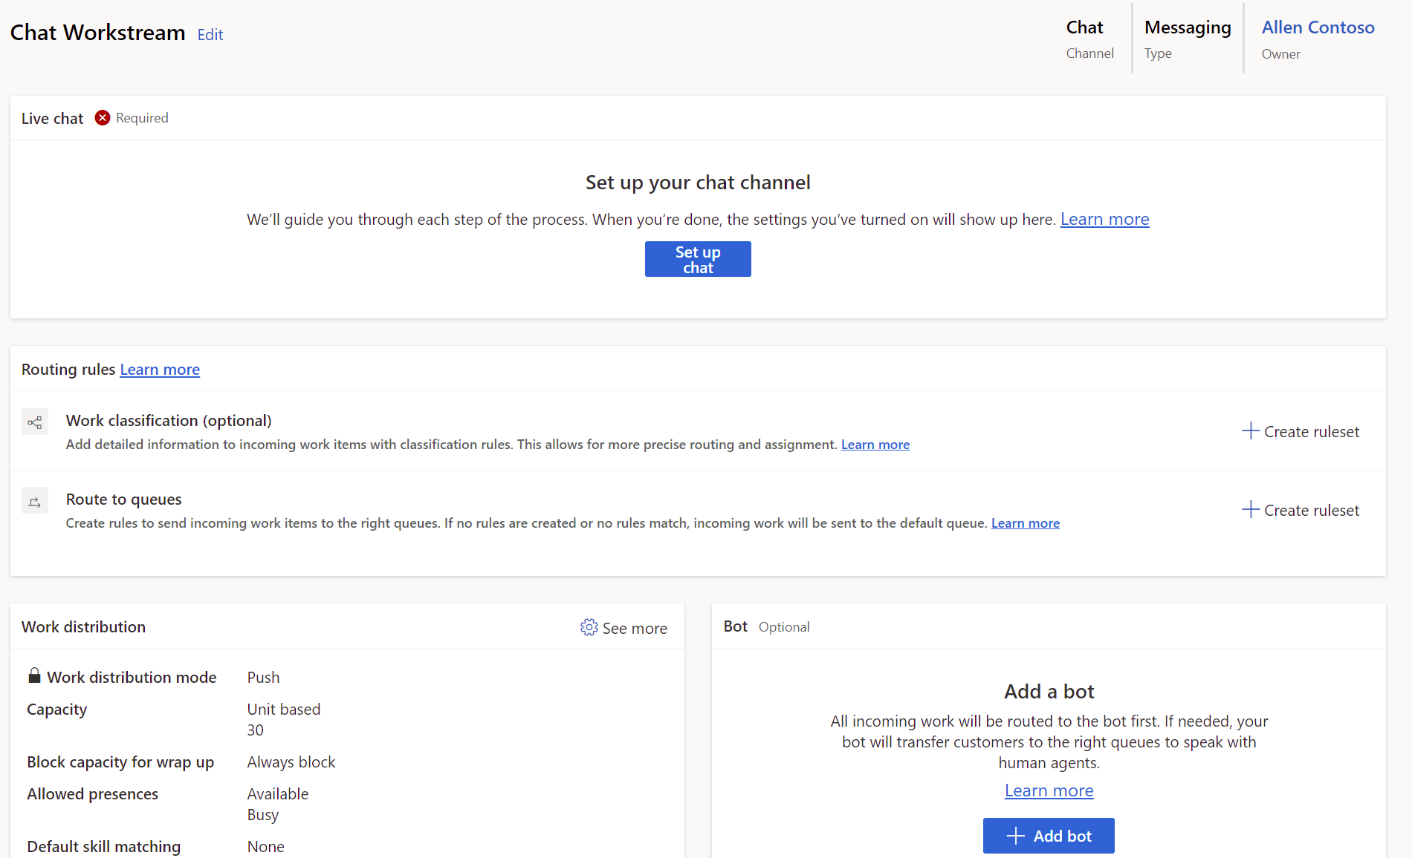

1. **Live Chat setup** screen will open. Enter the channel details as follows:
   1. **Name**: Chat Widget
   2. **Language**: English – United States
   3. Select **Next**.

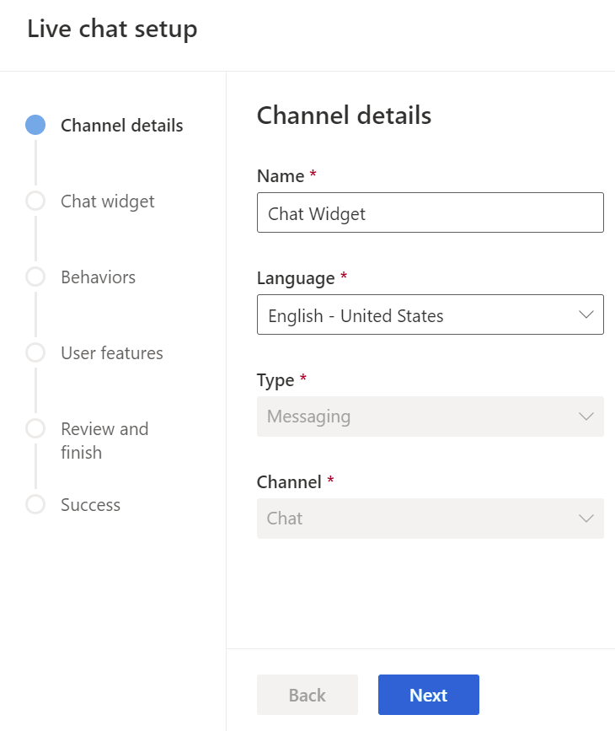

1. On the following screen, toggle to enable **Proactive chat.** Here you may define any additional settings for the chat widget.

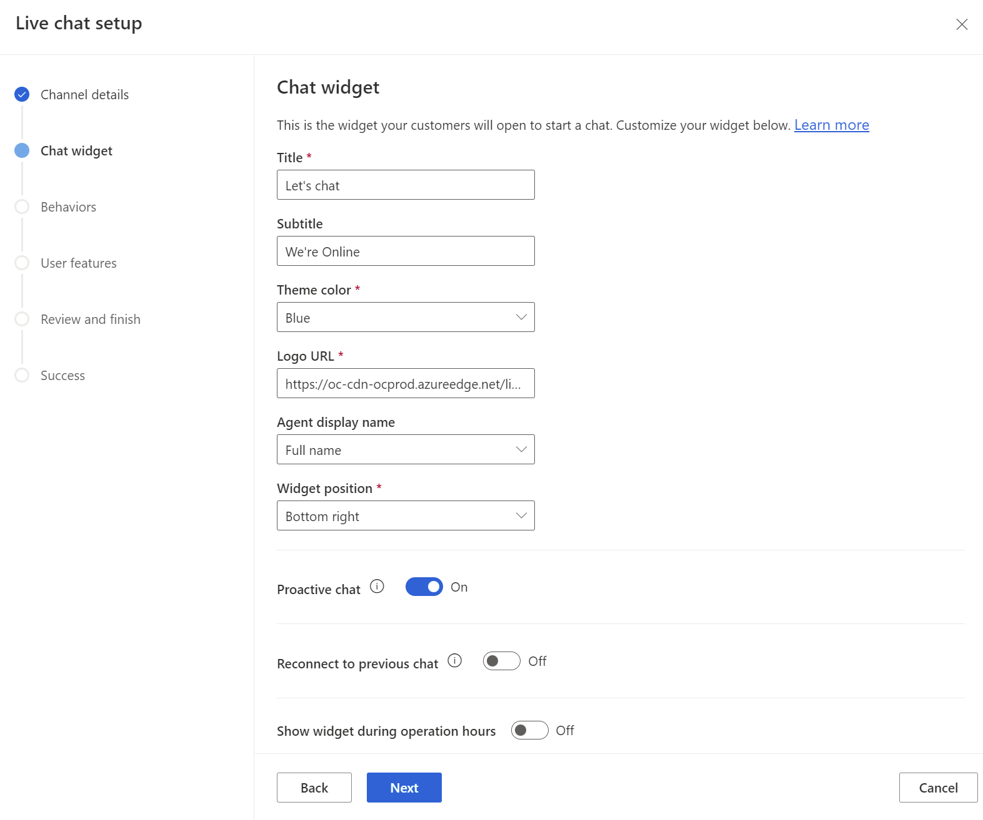

1. Click **Next** to see the **Behavior** settings you can customize for your bot, including automated messages and surveys. No need to customize anything here now.

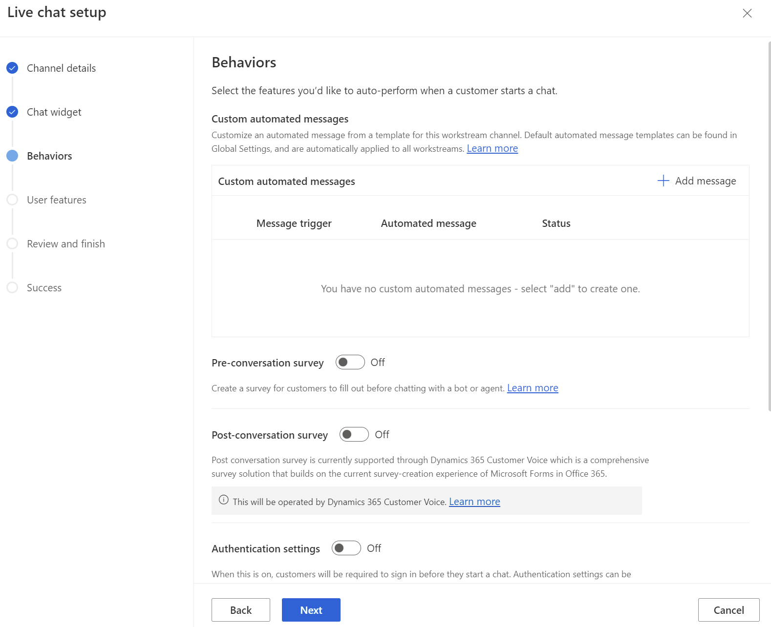

1. Click **Next** to see the **User features** that can be defined for the bot. Nothing is needed here now.

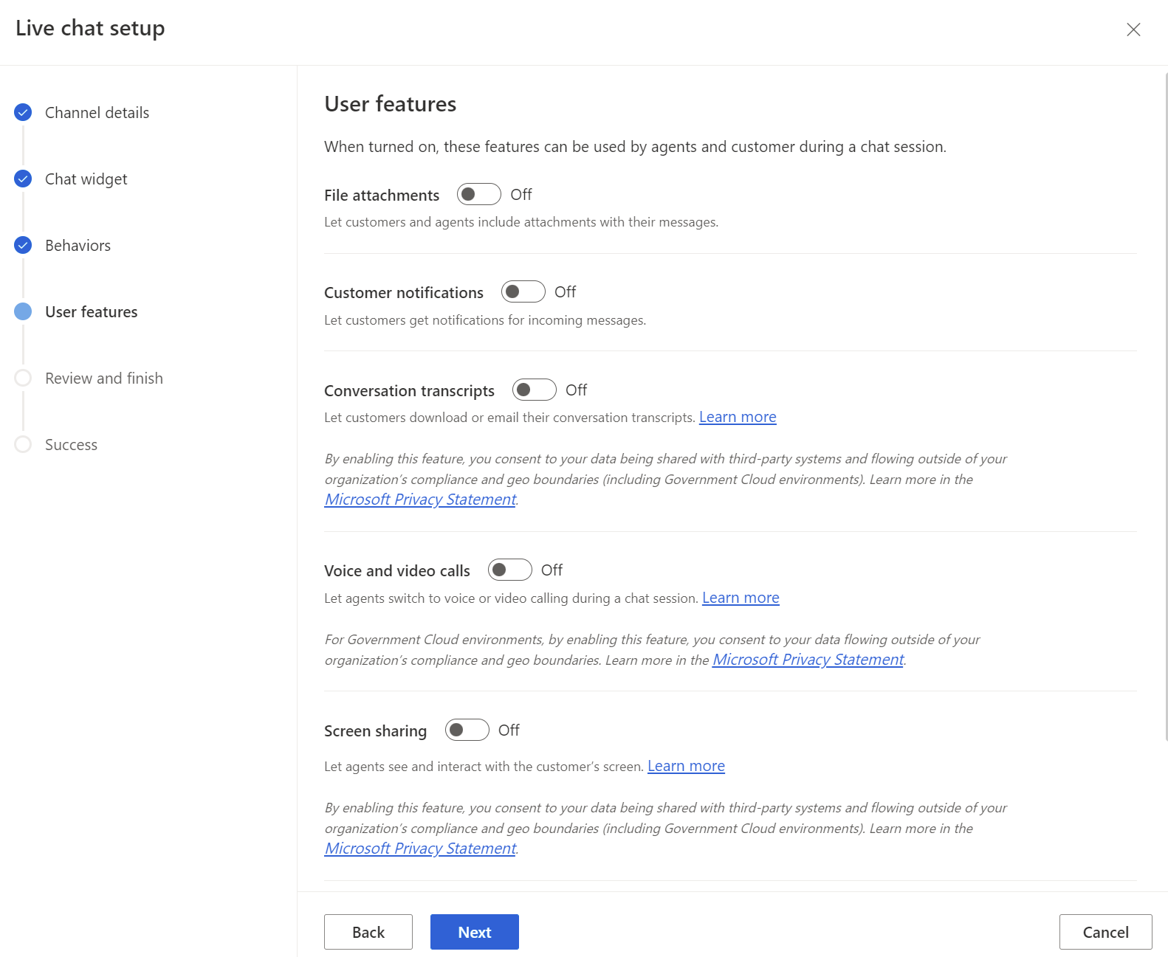

1. Review your settings and select **Create channel**.

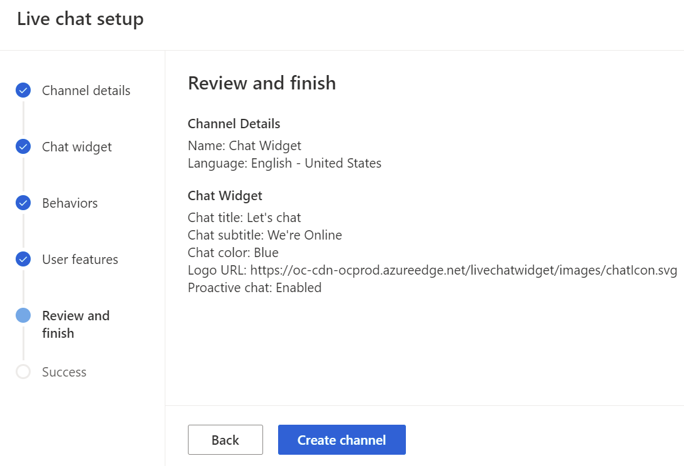

1. Once the chat channel is successfully created, **copy the script** of the chat widget, and save it somewhere to add it to your website later. Select **Done** toclose the wizard.

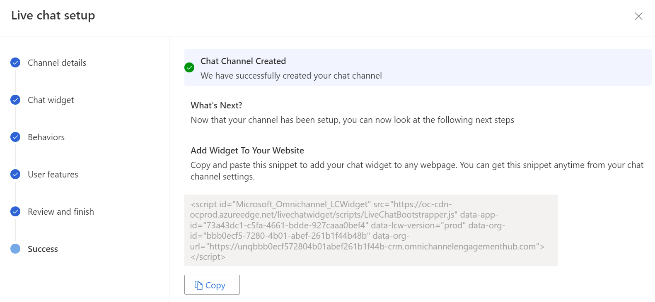

1. In your new **Chat Workstream** record, select **Add Bot** to add the Azure Health bot for initial routing.

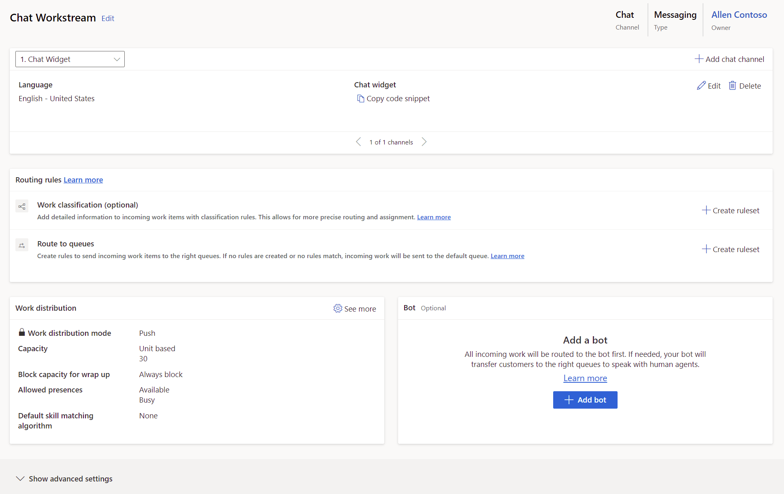

1. Find and **select** your bot. Click **Add**. *For official trainings, your bot should be called “MCH Application Id”.*

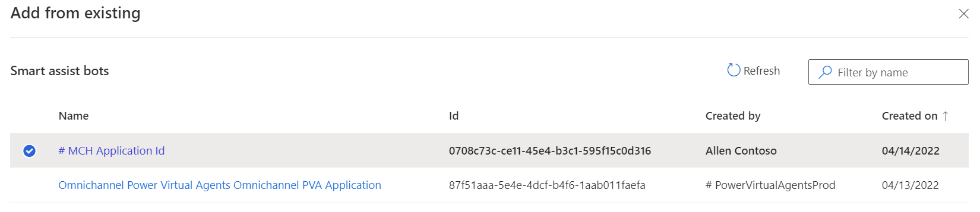

1. This should open the advanced settings and display your bot in the **smart assist bots** subgrid.

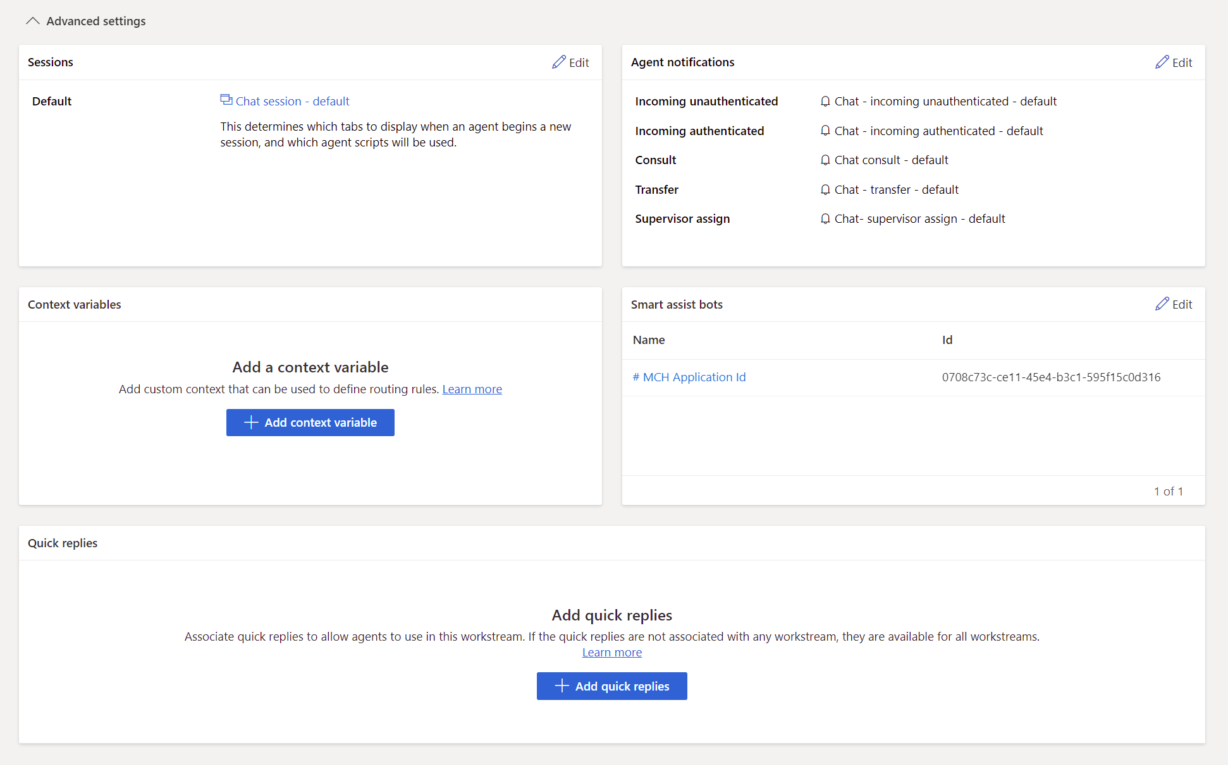

1. You can also access the advanced settings at the bottom of the record page by selecting **Show advanced settings.**



1. Now we want to define a new context variable and routing rule. Select **+ Add Context variable**.



1. In the context variable flyout, select **+ Add** to add new context variable.

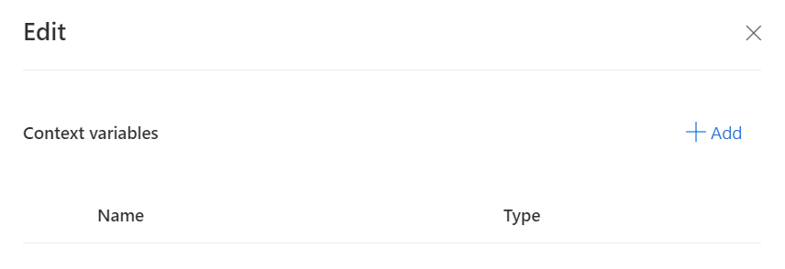

1. Create the new Context Variable with the following details:
   1. **Name:** EscalateToAgent
   2. **Type:** Number
   3. Click **Create**

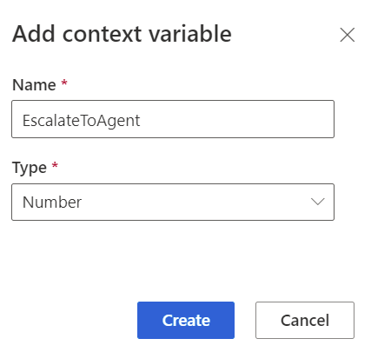

1. **Close** the context variable panel.

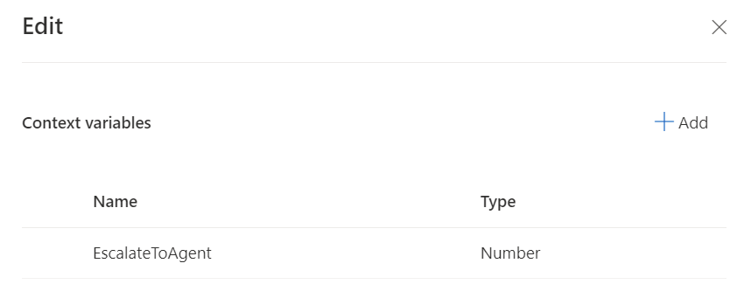

1. You should now see the new **EscalateToAgent** context variable in the live chat workstream.

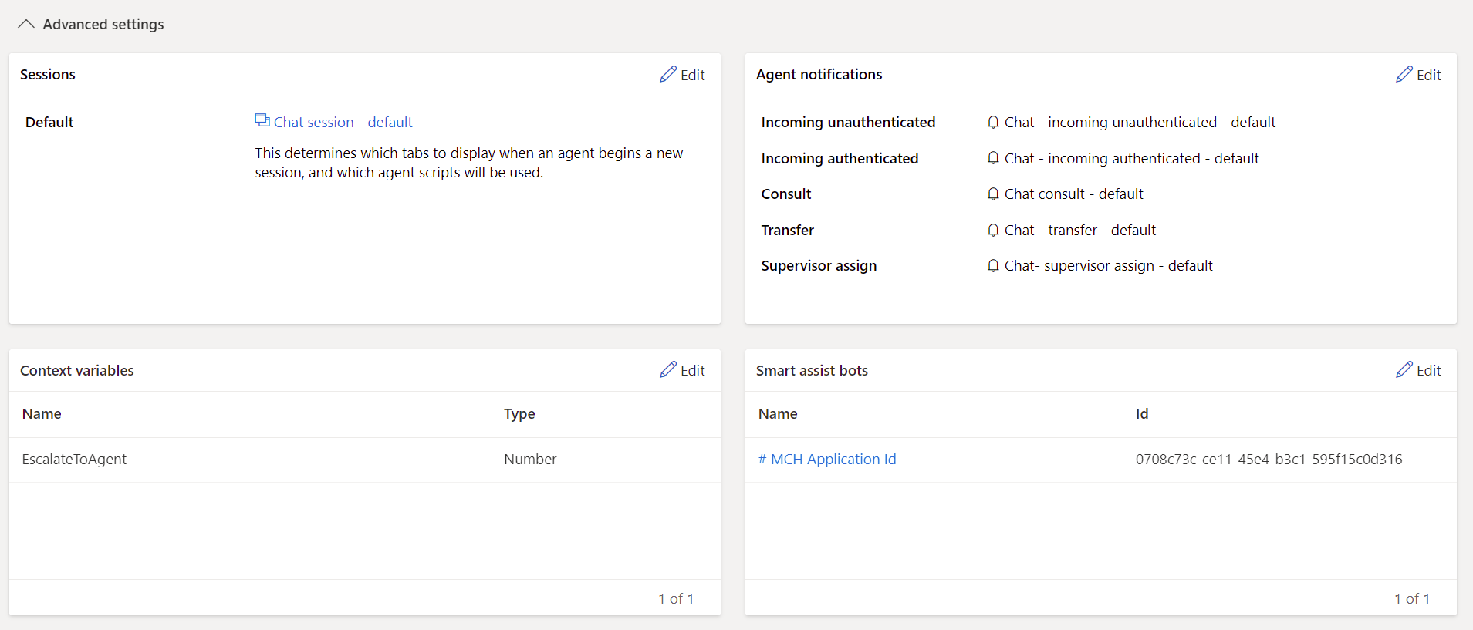

1. Select Advanced Settings to collapse to the main page.

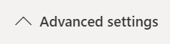

1. Under **Route to queues**, select **+Create ruleset**.

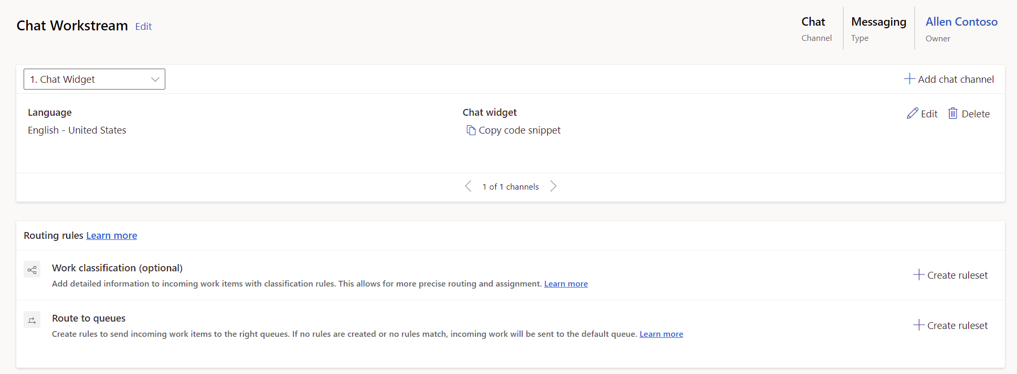

1. Create the new route-to-queues ruleset with the following details:
   1. **Name:** Human Agent
   2. **Description**: Escalate to human agent
   3. No Conditions.

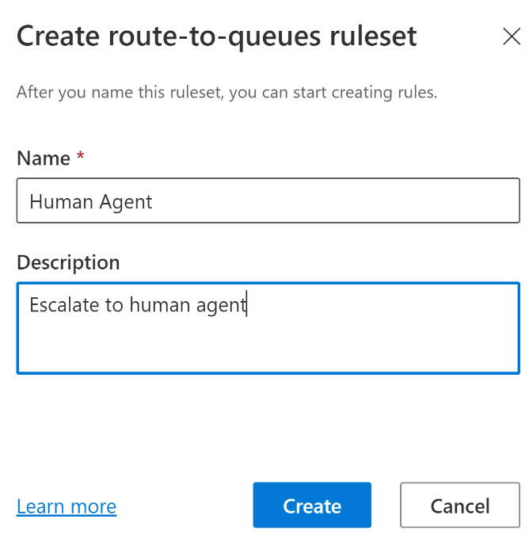

1. In the new Human Agent queue ruleset, select **+ Create** **rule**.

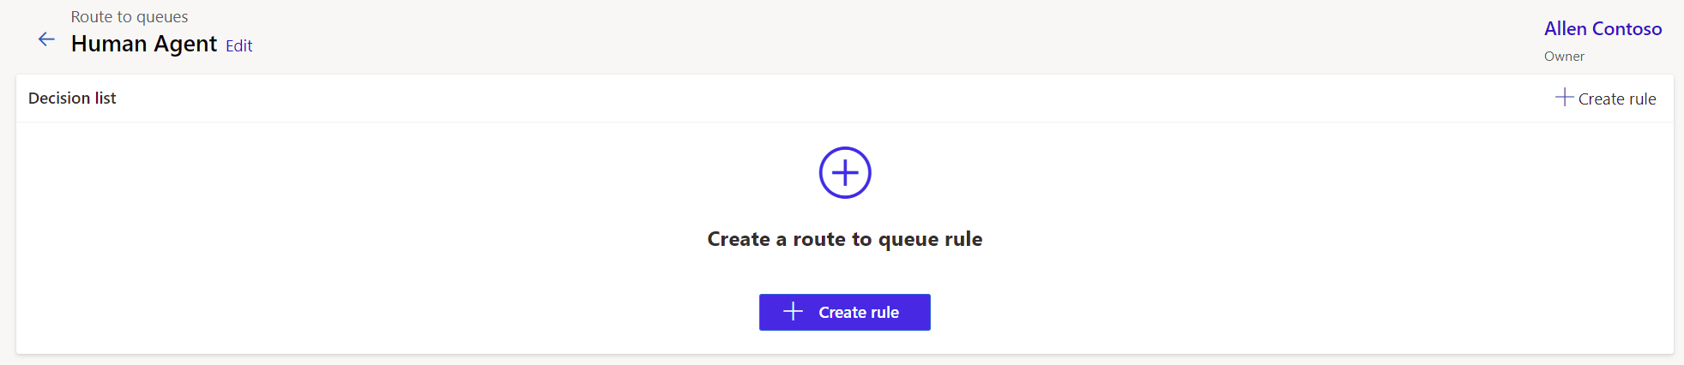

1. Name the new rule **Human Agent Rule**.

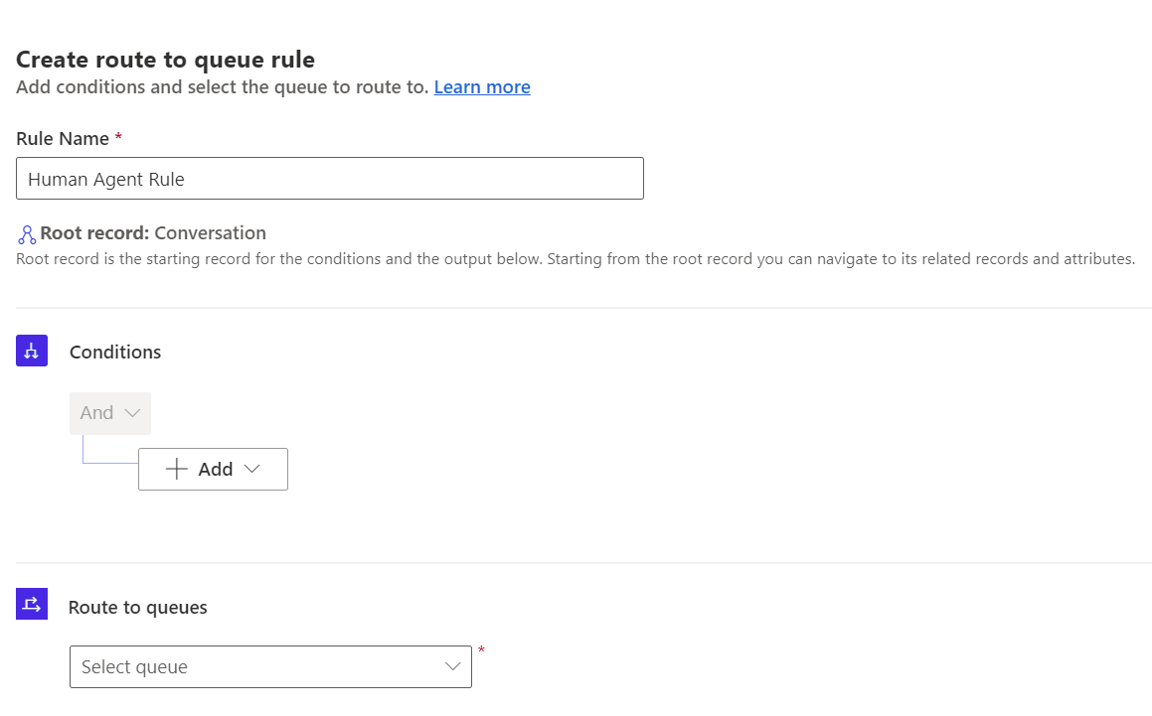

1. Under conditions, choose **“Add related entity”** from the dropdown.

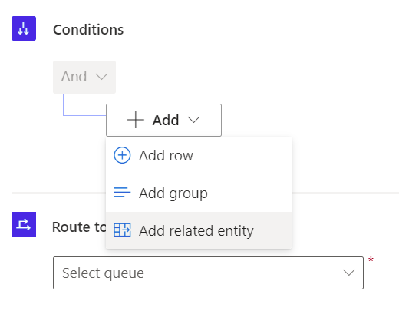

1. In the first two drop downs, Choose **Context item value** and **Contains data.** In the inline condition choose **EscalateToAgent Equals** **1**.

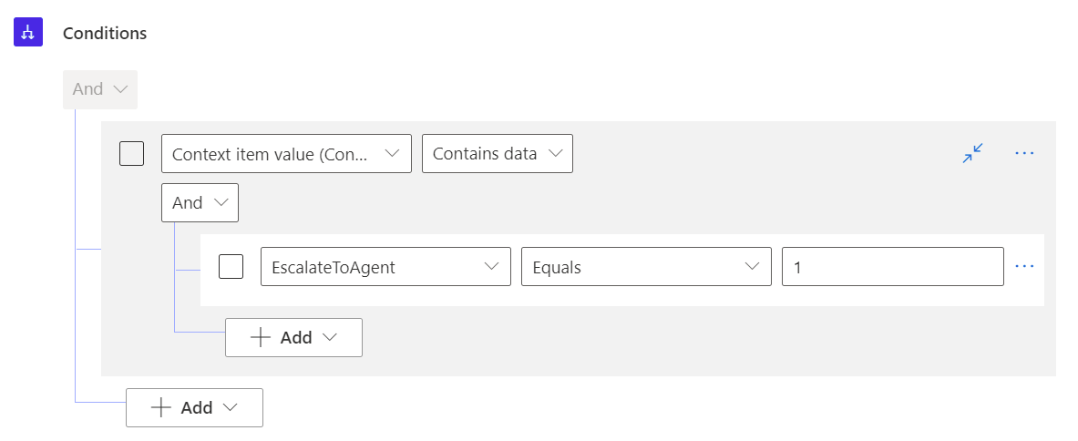

1. In the Route to queues section, choose **Escalate to Human** queue created previously.

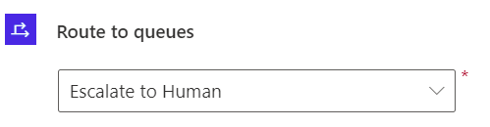

1. The configured rule set is shown below. Select **Create**.

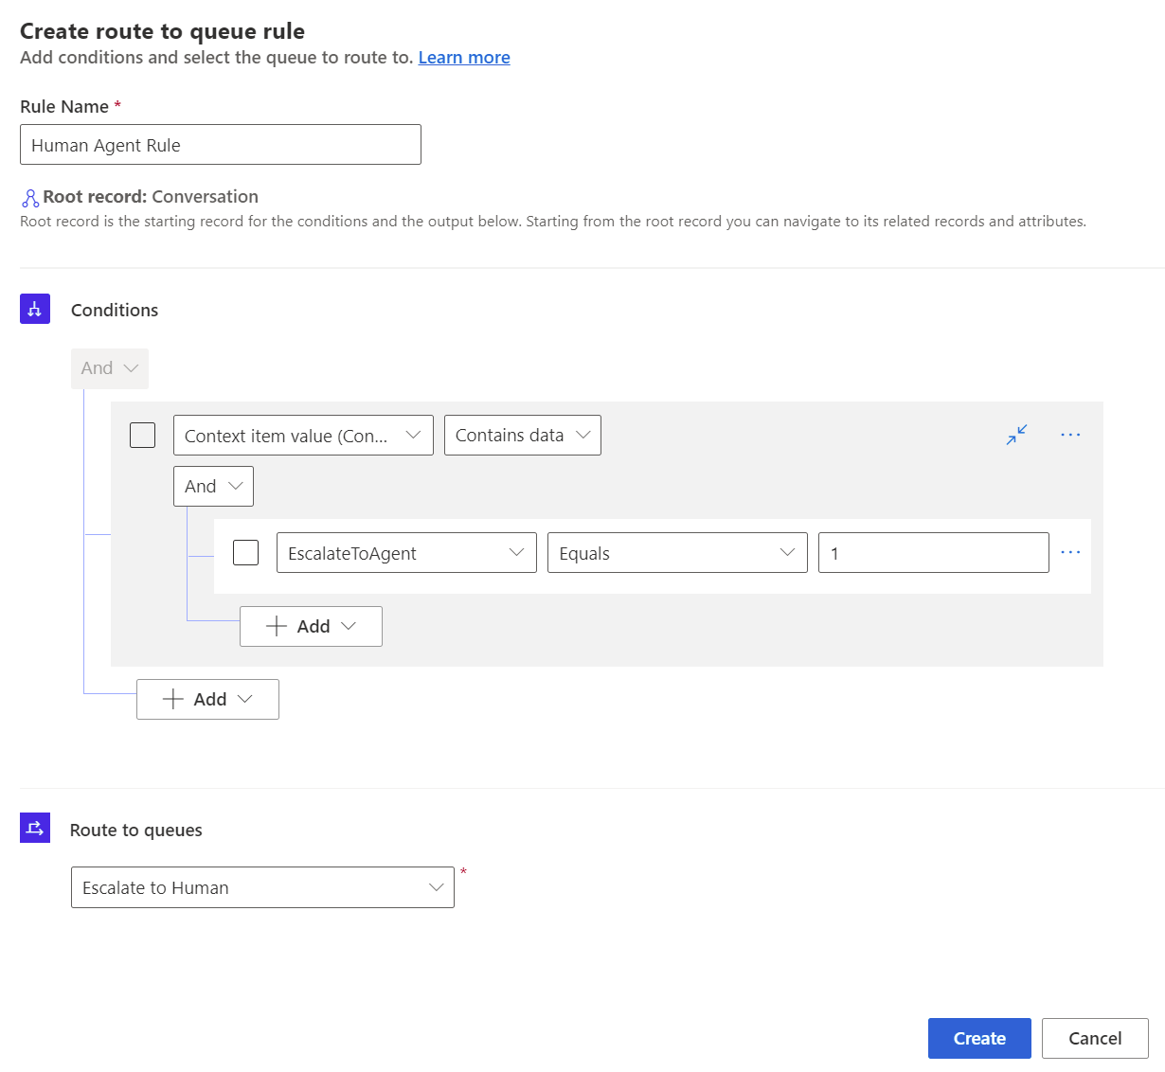

1. The Chat Workstream now has a Human Agent ruleset that will escalate to a human agent when the EscalateToAgent context variable is set to 1.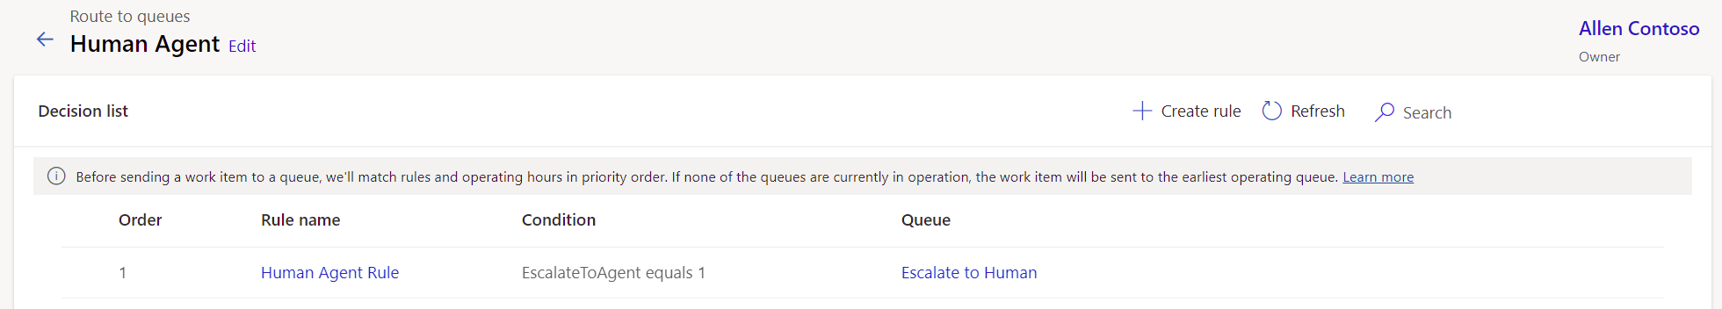

**Congratulations!** You have created a new Workstream with the proper live chat channel, smart assist bot, and routing rule that will allow customers to begin conversation with a health bot and escalate to a human agent.

Exercise 3: Embed Health Bot in Power Apps Portal

In this exercise, you will be embedding the **Omnichannel Chat Widget** into the Power Apps Customer self-service portal using Portal Management configuration. In your environment, we created a Lamna Healthcare Company Portal using the **Customer self-service portal** template before deploying Microsoft Cloud for Healthcare. Now we will configure the chat widget to show on the customer website.

**Customer self-service portal**: A customer self-service portal enables customers to access self-service knowledge, support resources, view the progress of their cases, and provide feedback.

**Portal Management**: Application to help you get started with the advanced portal configuration. In this walk-through, you will learn how to configure Chat widget in **Portal Management** app.

1. In <http://make.powerapps.com>, open the **Portal Management** app. 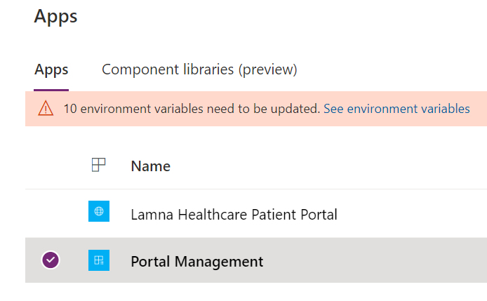
2. Select **Content Snippets** in the left navigation pane

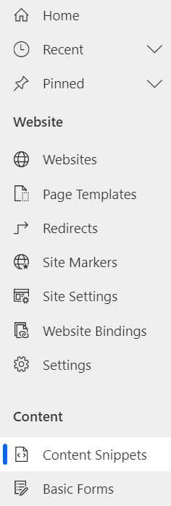

1. In **Active Content Snippets**, type “**Chat**” in the **Search** box and press enter.

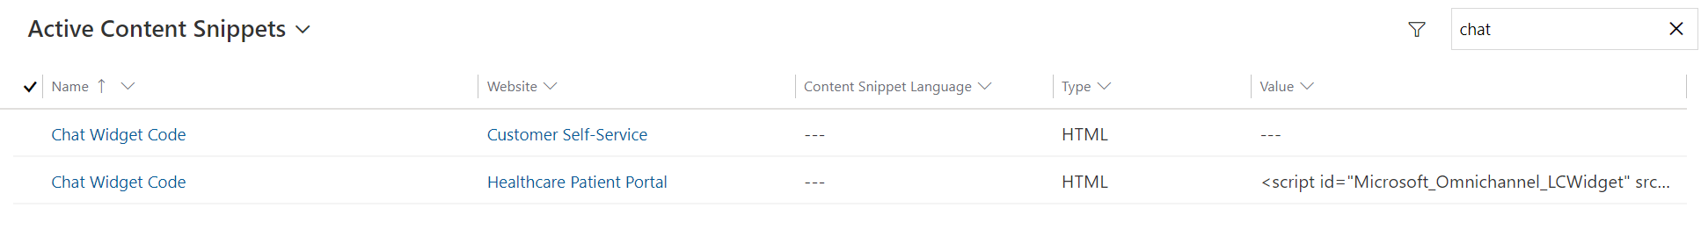

1. You will see two **Chat Widget Code** records retrieved in the list.

Click to open the Chat Widget Code record related to **Customer Self-service.**

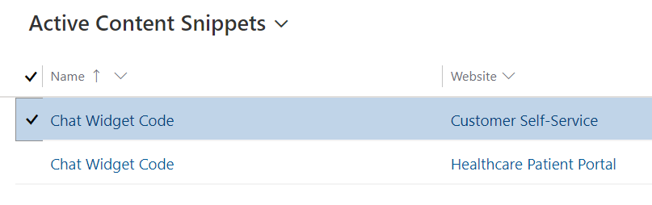

1. In the **Chat Widget Code** record associated with Customer self-service, select **Value (HTML)** > **Html** Tab and then paste the **Chat Widget Code snippet** that you copied and stored in the previous task.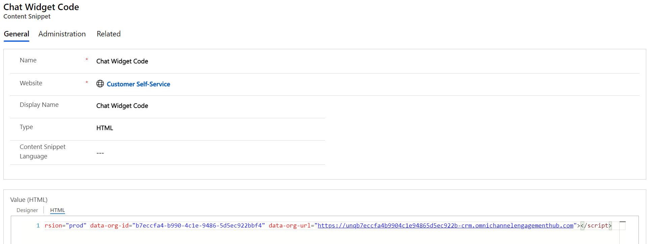
2. Click **Save & Close**.

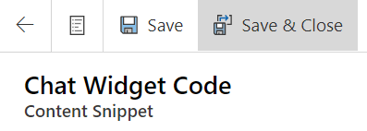

1. Now open the other **Chat Widget Code** associated with the **Healthcare Patient Portal** website.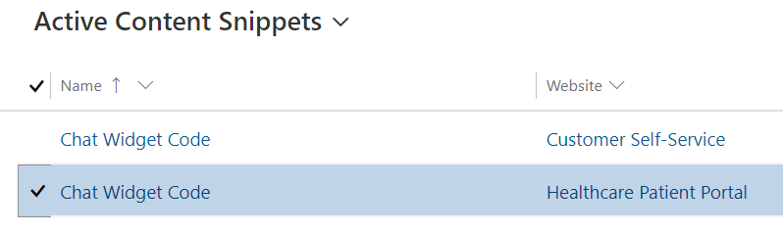
2. In the **Chat Widget Code** record associated with the Healthcare Patient Portal, paste in **Value** (HTML) the same **Chat Widget Code snippet** that you copied and stored previously and added to the customer self-service chat widget code. Replace any value that may have already populated the field.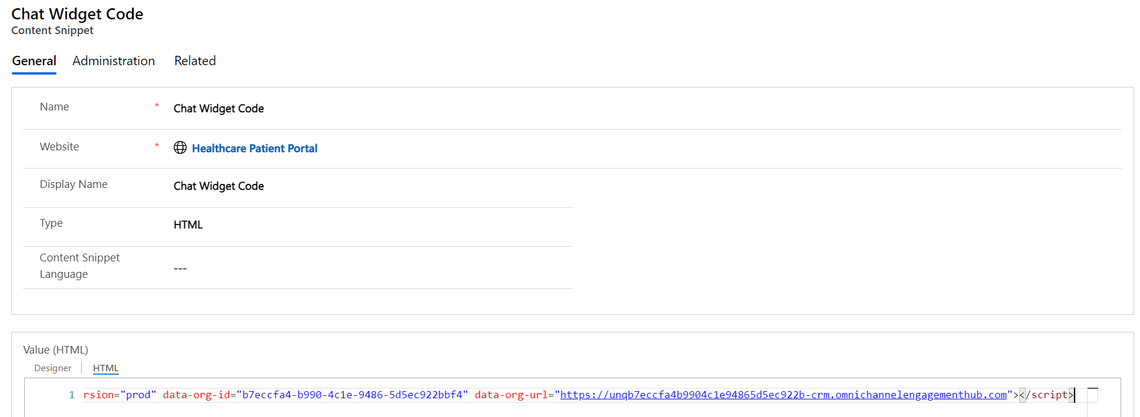
3. Select **Save and Close**.

**Congratulations!** In this exercise you have successfully updated the chat widget in the Power App Portal Content Snippets. With this configuration, the Health Bot will be visible on the Power Apps portal for both the customer self-service template and the healthcare patient portal template.

Exercise 4: Extend Azure Health Bot with Custom Scenarios

**Dynamics 365 Omnichannel** integration allows the patient to interact with **Azure Health Bot** using the Dynamics 365 chat widget to access the medical knowledge and your custom scenarios. It also, allows the escalation of a bot conversation to a live agent to continue the interaction. When escalating a conversation, Dynamics passes along the conversation history and the context to the agent.

In this exercise, you will be doing the following:

1. Designing the below Health Bot Scenario called **MCH_PatientService**

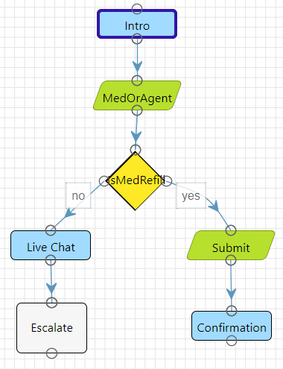

**“Intro” statement card is used to trigger a welcome message to customer.**

**“MedOrAgent” card is to prompt with Medication Refill/Live Agent action authored card.**

**“IsMedRefill” Decision card is used check the variable and submit a Medication Refill or start Live Chat.**

**“Submit” card is to prompt an adaptive card message (Input text) with Name, Email, Medication Name**

**“Live Chat” card is to communicate to the customer they are being directed to a live agent.**

**“Confirmation” card is to repeat any information gathered from the submission and thank the customer.**

**“Escalate” card is used to trigger a escalate to Live Agent message on Dynamics 365 Omnichannel for Customer Service.**

1. Design another Health Bot Scenario called **MCH_PatientServiceWelcome**. This scenario holds the starting statement which will allow the user to invoke the **MCH_PatientService** scenario.
2. Set the **Automatic Welcome Scenario** to be the MCH_PatientServiceWelcome custom scenario you create. This will begin the scenario when a user first interacts with the Health Bot.

Task 1: Create MCH_PatientService Scenario

In this task, you will create the **MCH_PatientService** bot scenario using the designer canvas.

Navigate back to the Azure Health Bot instance homepage where you set the bot settings. This is the portal management link you copied from the Azure portal.



1. Click to Expand the Side navigation bar. Navigate to **Scenario** > **Manage.**

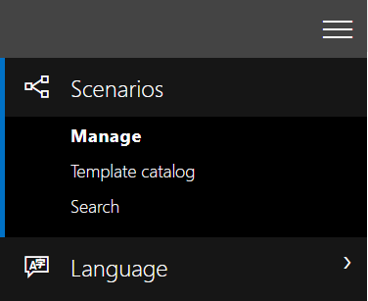

1. Click **+ New** button on the top ribbon.

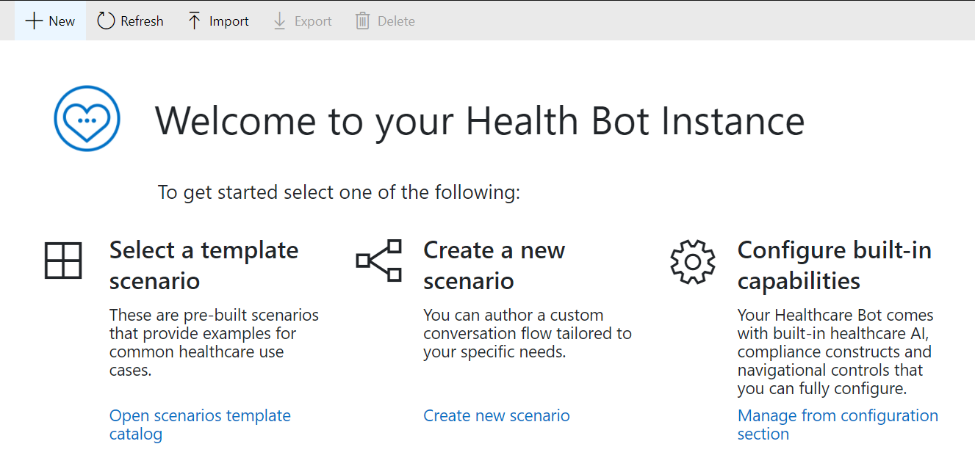

1. Provide the following details for the new health bot scenario:
   1. **Name**: MCH_PatientService
   2. **Scenario ID**: MCH_PatientService

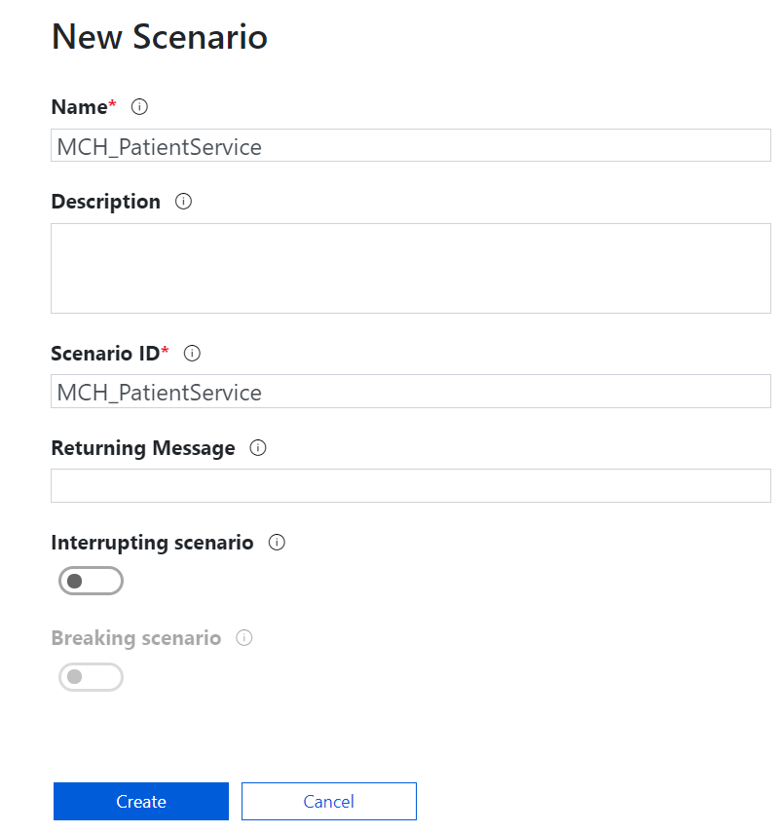

1. Now let’s design the scenario conversation. It should navigate you directly to the designer. If not, select the MCH_PatientService scenario in **Scenarios** > **Manage** to edit.

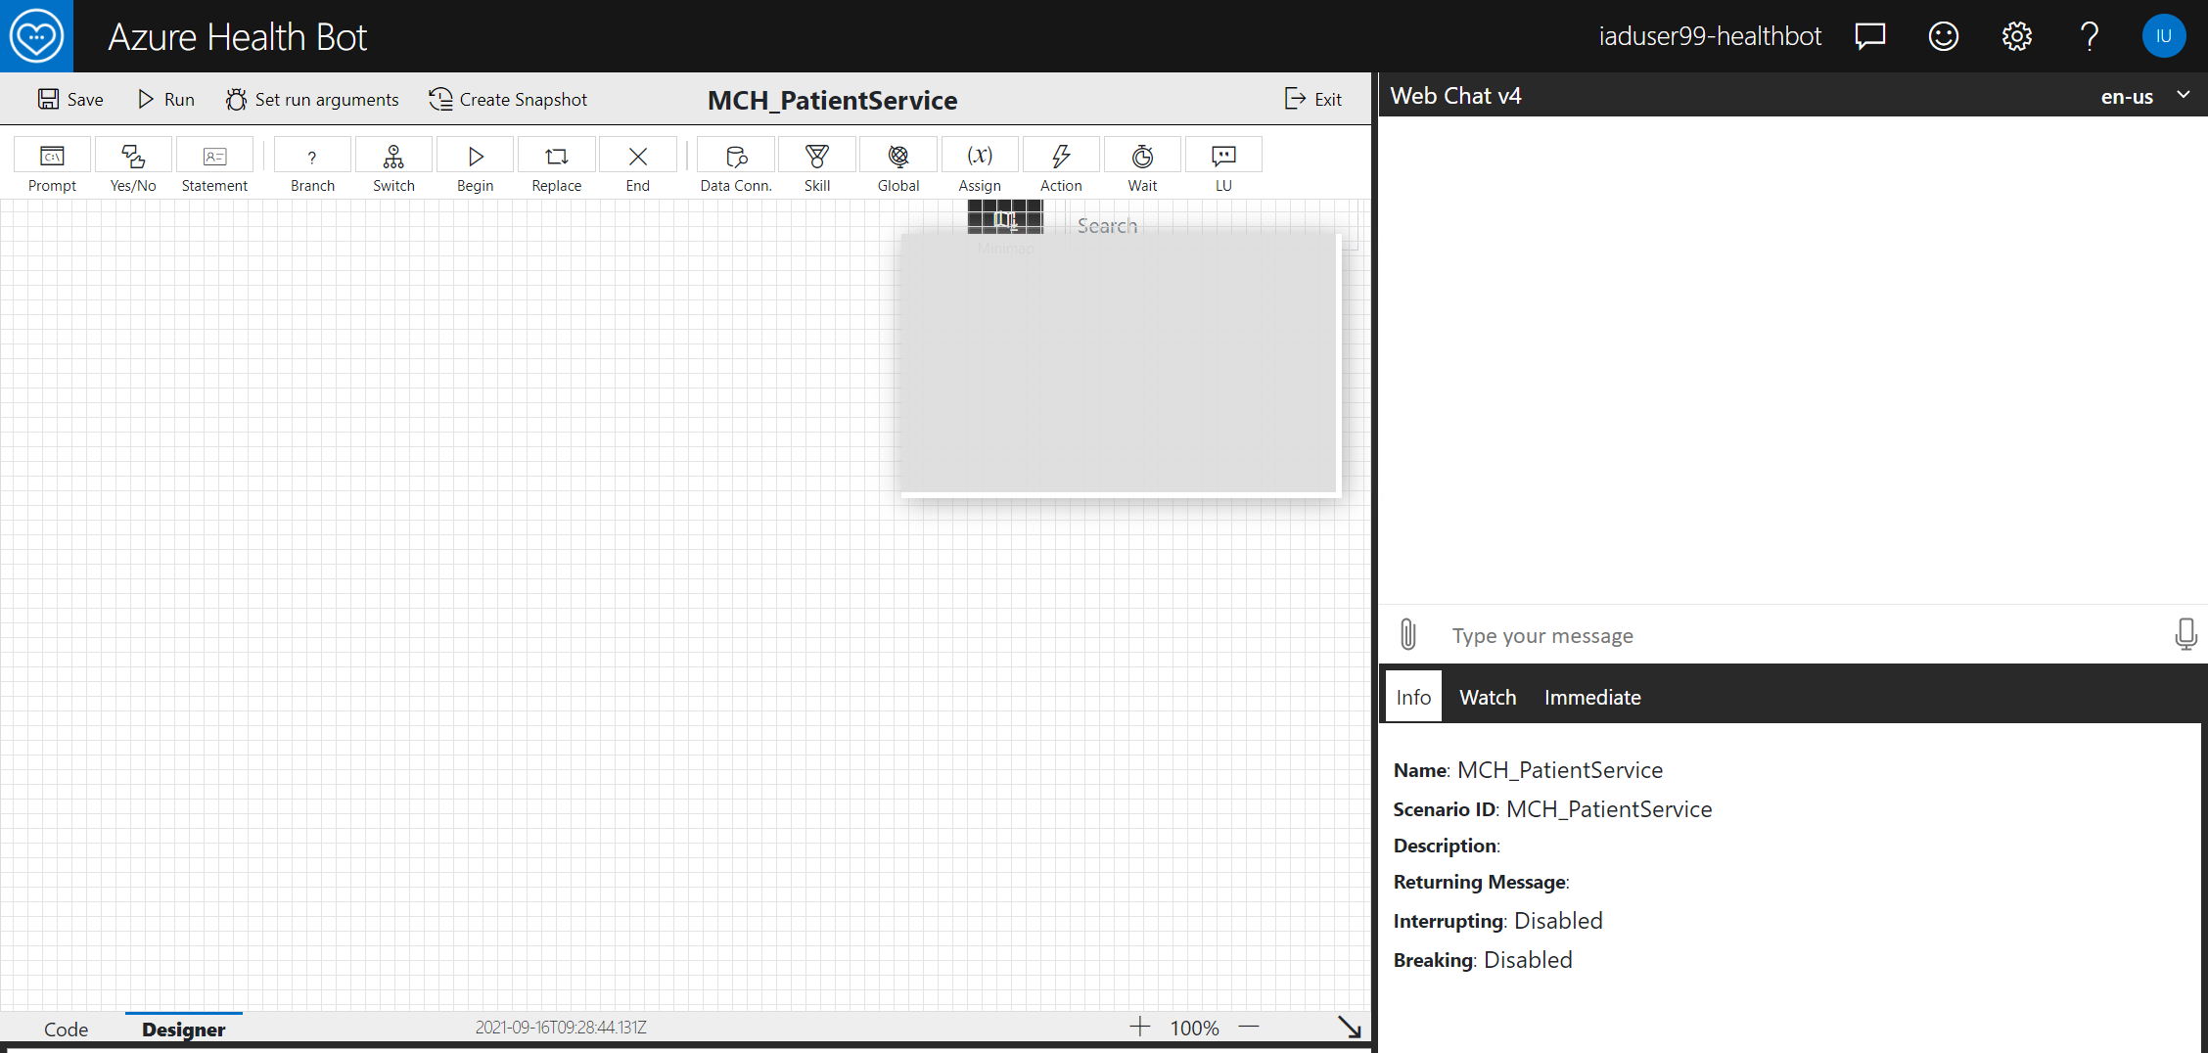

Step 1: Add Bot Introduction Statement

1. Add a beginning **Statement** to the scenario by **selecting** the icon **and** **dragging** Statement icon onto the editor.

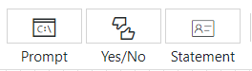

1. Enter the **Display Text**:

Hi there, I’m your Healthcare Assistant.

1. Select the **pencil** next to Statement in the top bar and Change Title to “**Intro**”. Click **OK**.

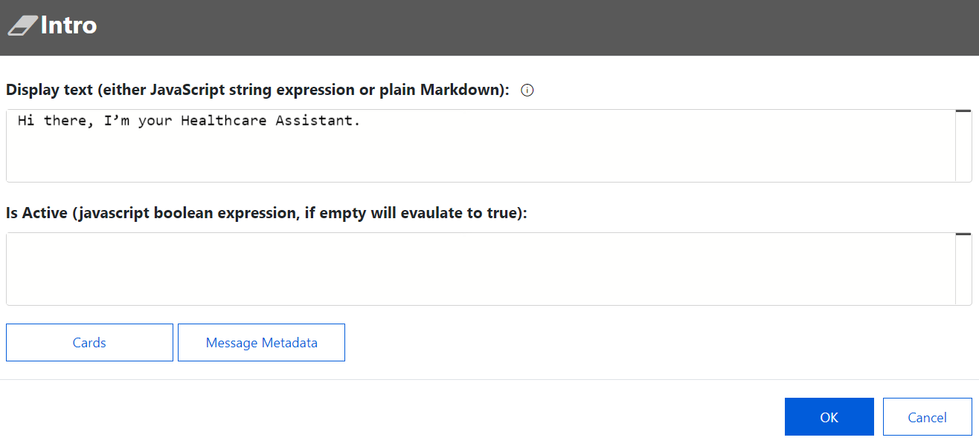

1. Click **OK**. You will see the intro statement added to the designer canvas. Double click anytime to edit.

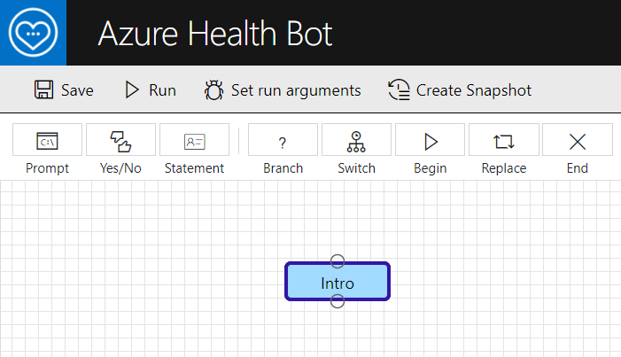

Step 2: Add Statement for Medication Request or Live Agent

This section prompts two buttons Medication Refill and Live Agent. When user click any one of the buttons it will set the appropriate text to the variable MedicationOrAgent.

1. Select **Prompt** icon and drag down onto canvas



1. Enter the following details:
   1. **Display Text**: Would you like to request a medication refill or chat with a live agent?
   2. **Variable name:** MedicationOrAgent
   3. **Data type**: string
   4. Rename title to **MedOrAgent**.
   5. Click **Cards** button.

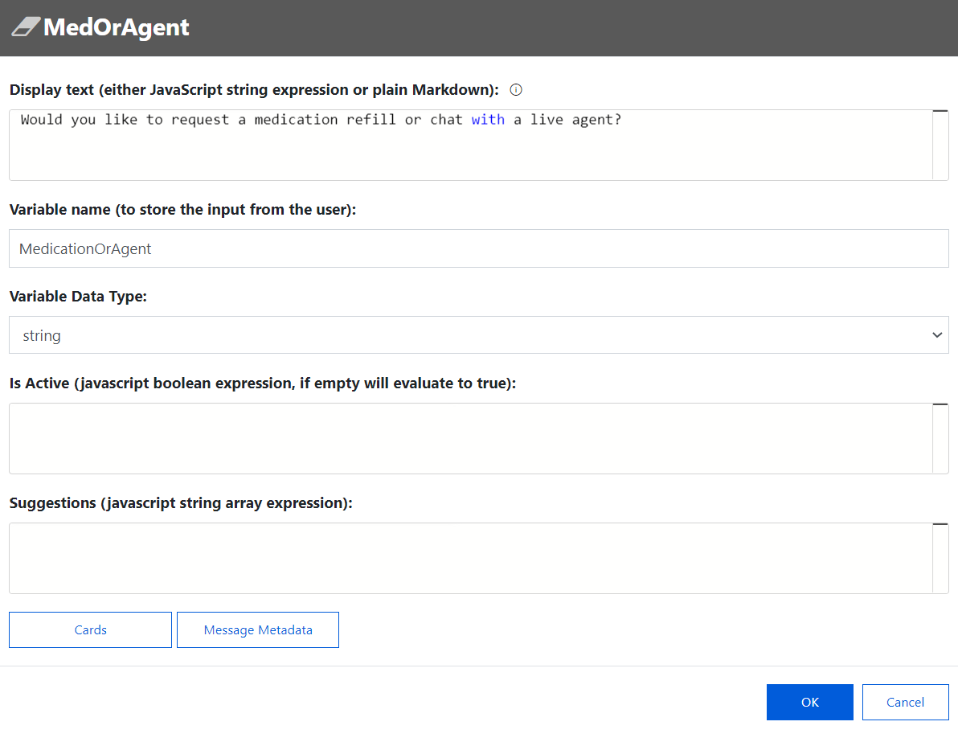

1. Select **Add Card**.

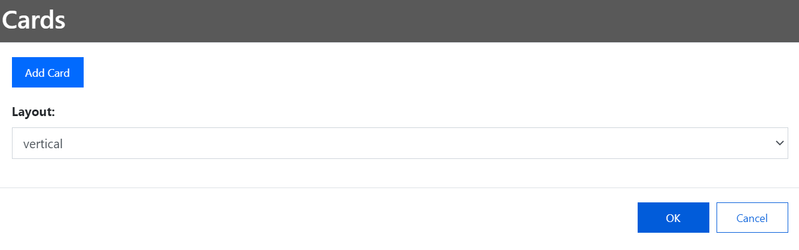

1. Select Card Type as **HeroCard.** Leave title blank as we already prompted with display text.
2. Click **Add Action** button twice to add two actions:
   1. For the first action, select the following:
      1. Action type: imBack
      2. Action value: MedicationRefill
      3. Action title: “Medication Refill”
   2. For the second action, fill in the following:
      1. Action type: imBack
      2. Action value: LiveAgent
      3. Action title: “Live Agent”

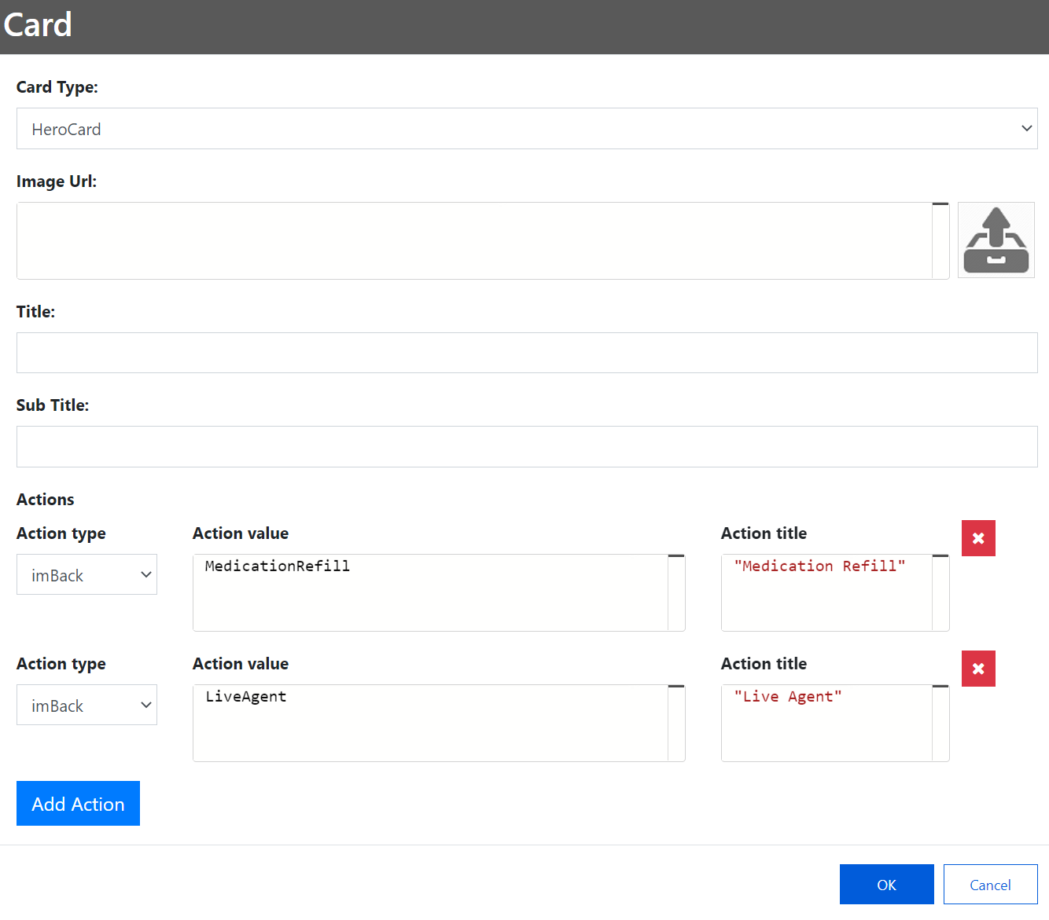

1. Click Ok three times to get back to designer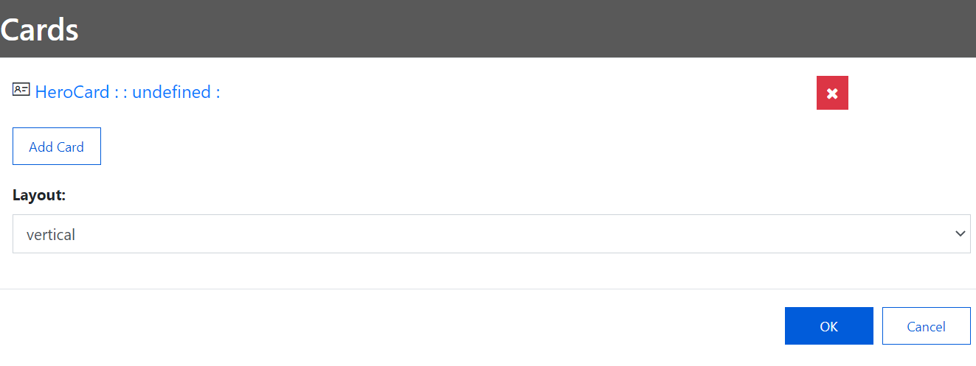

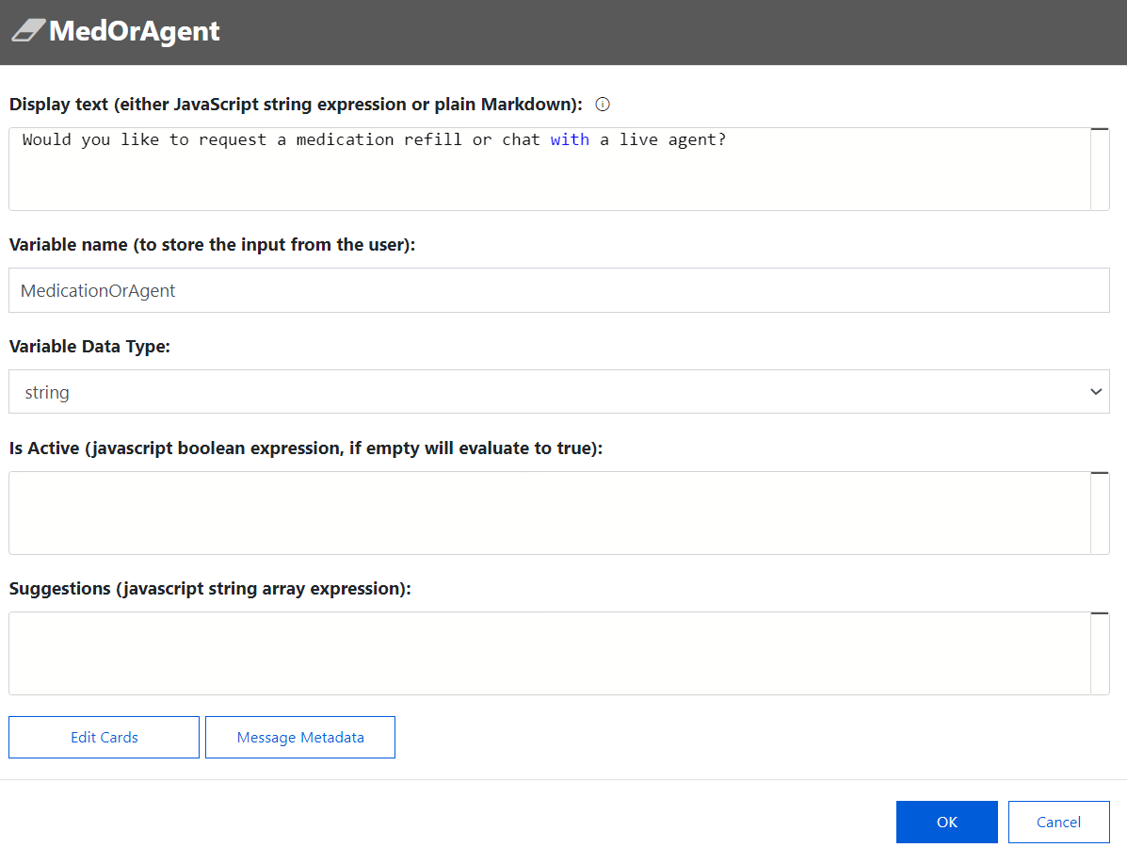

1. Connect Intro and Appointment boxes. Select the bottom circle on intro and drag it to the top circle on the new prompt. An arrow will automatically appear when you try to connect Intro and MedOrAgent boxes using ellipse pointer.

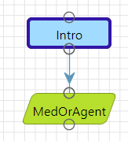

1. Select **Save**.

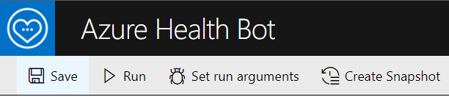

1. Select **Run** to see the output in the WebChat on the right.

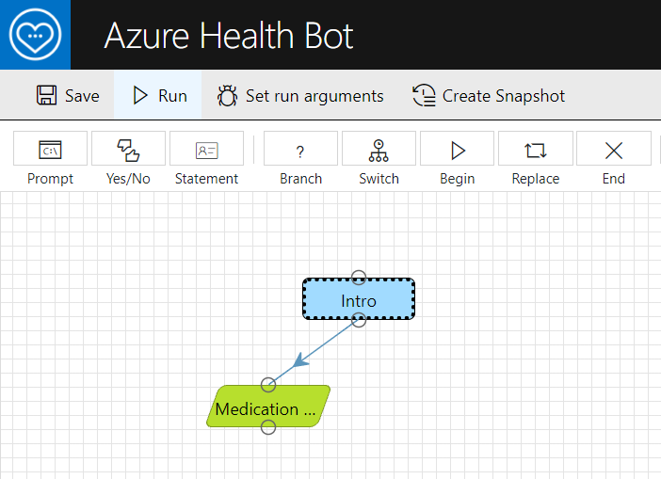

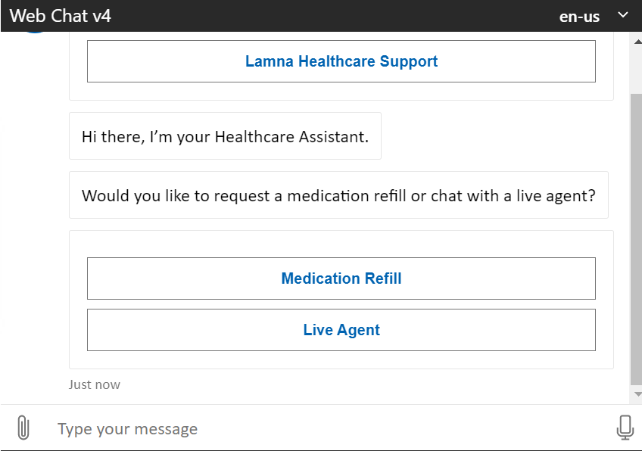

Step 3: Add MedicationOrAgent Decision Branch

This section checks whether the user has clicked Medication Refill or Live Agent with the help of the variable MedicationOrAgent. It will redirect the message accordingly.

1. Add a **Branch** to the designer canvas**.**

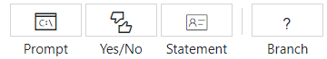

1. Enter the following in the **javascript Boolean expression**:

scenario.MedicationOrAgent === "MedicationRefill"

1. Rename to **IsMedRefill.** Select **OK**.

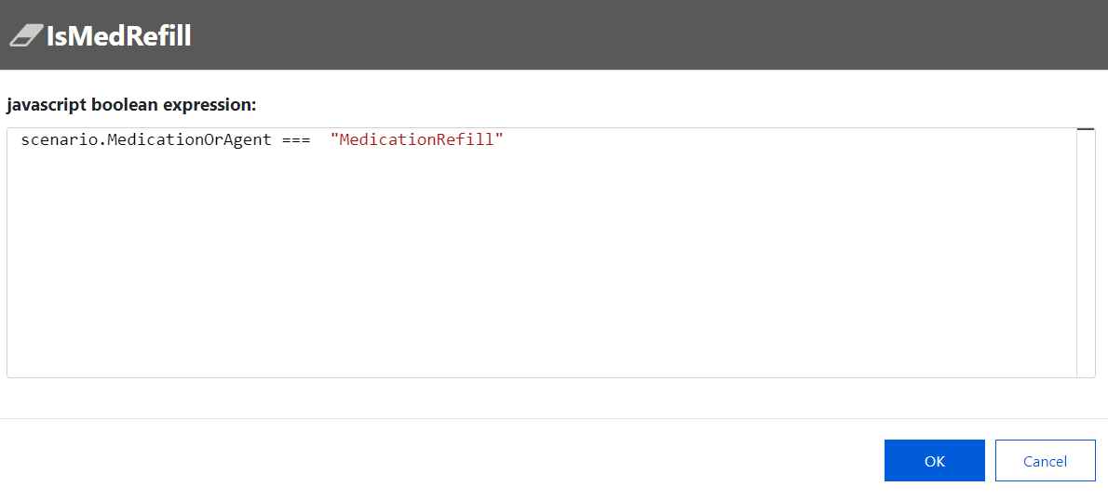

1. Select and drag the bottom circle of the **MedOrAgent** prompt to the top circle of the **IsMedRefill** branch decision to connect them.

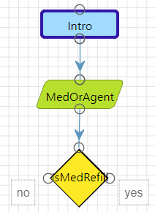

Step 4: Prompt User to Enter Data for Medication Refill Option

1. Add a **Prompt** element. This will be used to display the Form data (using Adaptive Card) to capture Patient name, email, and phone to create an appointment.



1. Add the following details:
   1. **Variable name**: formData
   2. **Variable Data Type**: Object
   3. Change Title to **Submit**
   4. Do not add any display text since the adaptive card will display instead

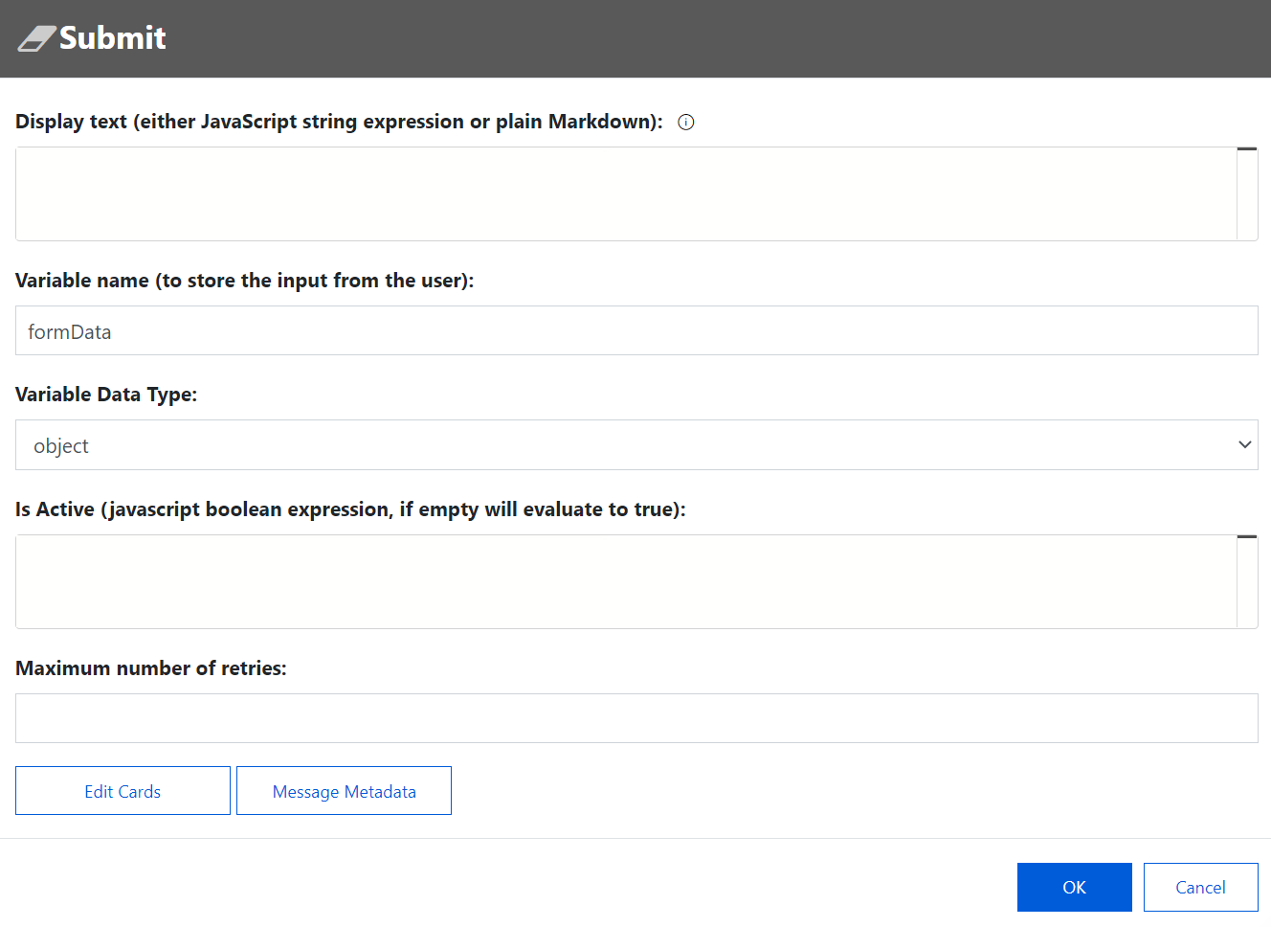

1. Click **Cards** button > **Add Card** > **Adaptive Card**.
2. Refer to the lab resources file **AdaptiveCardForMedicationRefill.txt** and copy the json content and paste it in the json section of your card.

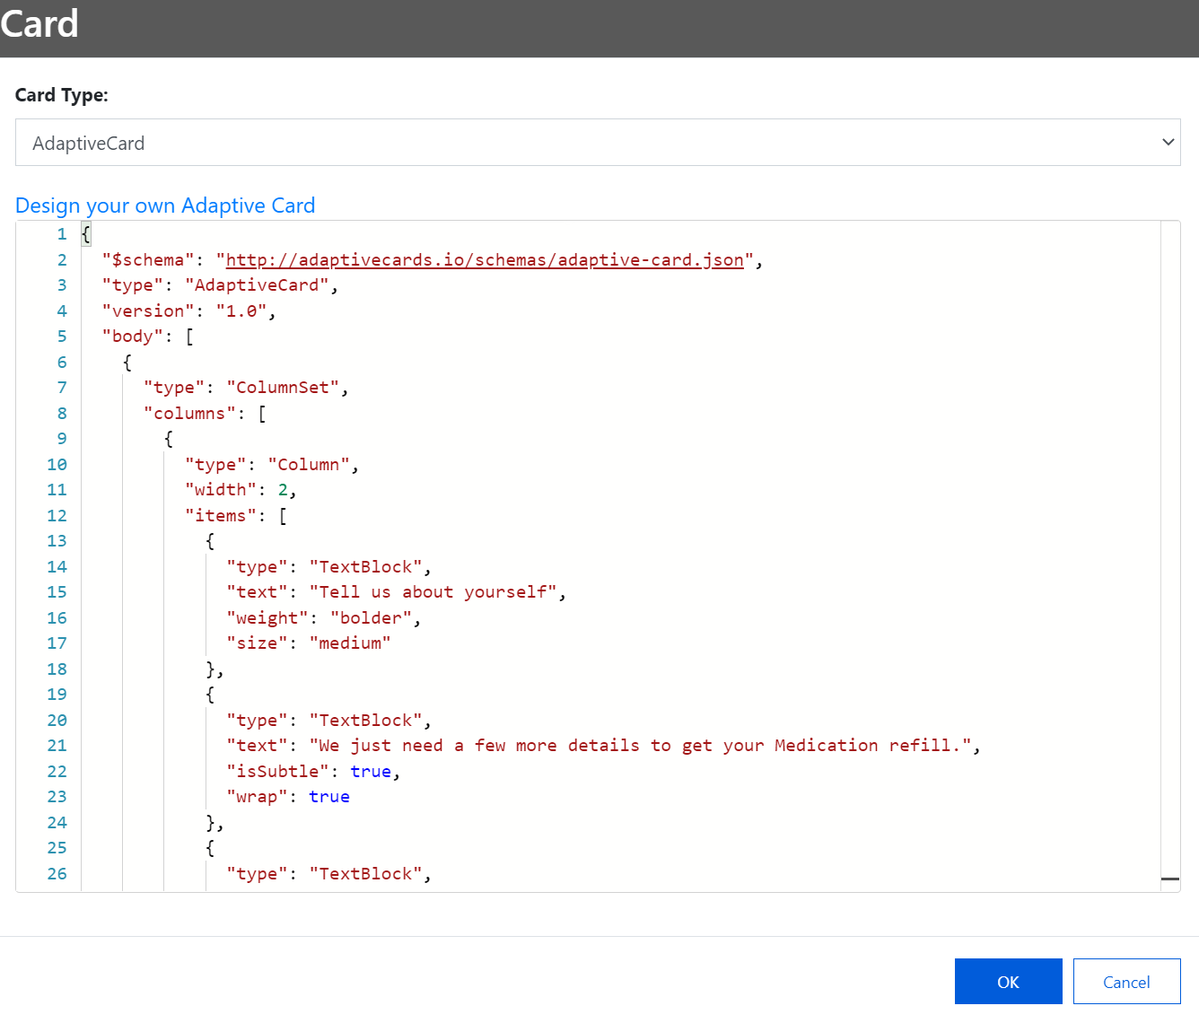

1. Select **OK** three times to get back to the designer.
2. **Connect** the **Yes** condition of the **IsMedRefill** branch to the **Submit** prompt.

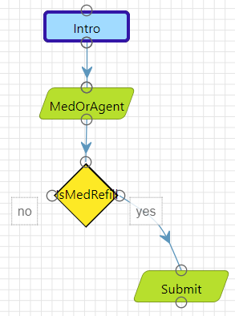

1. **Save** and **run** your current scenario. If you don’t save the scenario first, it won’t run with updates since the last save. If you haven’t saved at all, it won’t recognize any conversation.

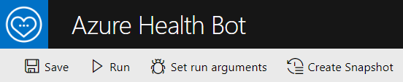

1. You should see the below output when running the conversation and selecting “Medication Refill” card when prompted to show the AdaptiveCard.

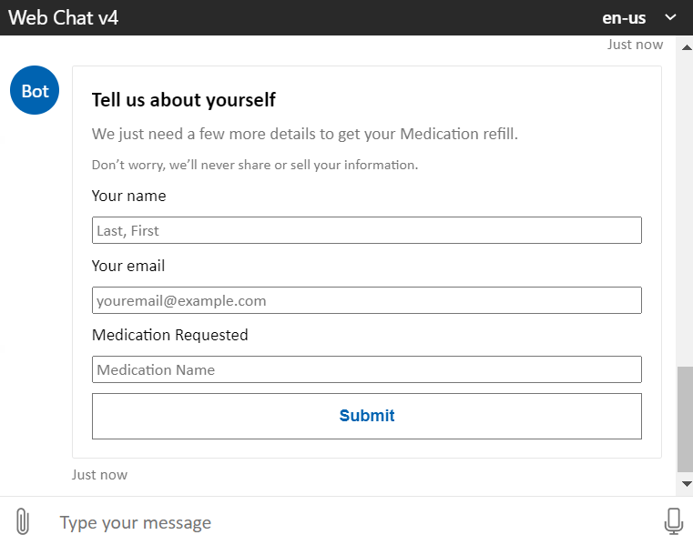

Step 5: Add Confirmation Statement

1. Add a **Statement** element.



1. Add **Display text** as the following:

scenario.formData.myName + " - Thanks for providing the information, we have created a Medication Request for you regarding the following medication: " + scenario.formData.myMedReq

1. Rename the statement to **Confirmation**.

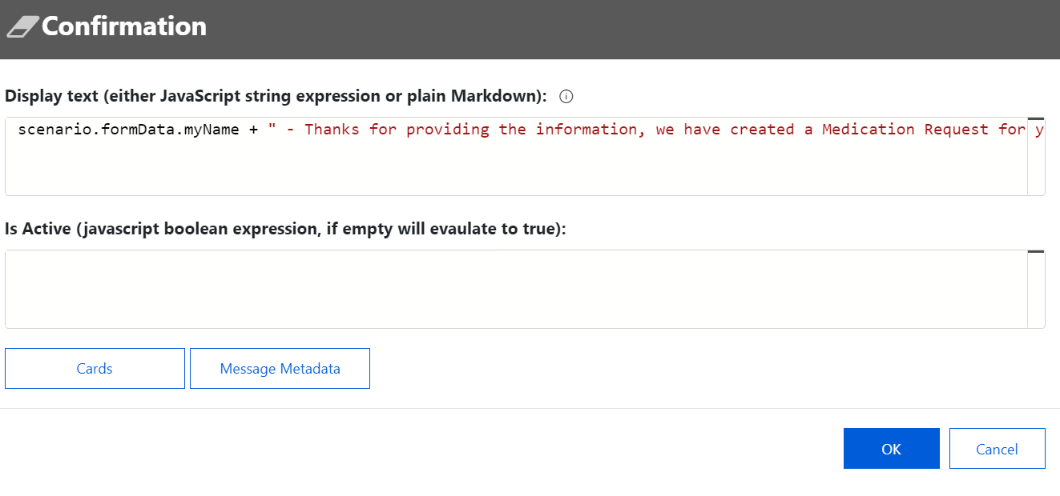

1. Connect the Submit step to the Confirmation step in the designer canvas.

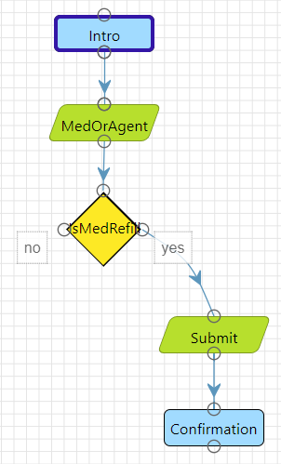

1. Select **Save** and **Run** to see your scenario in the webchat.

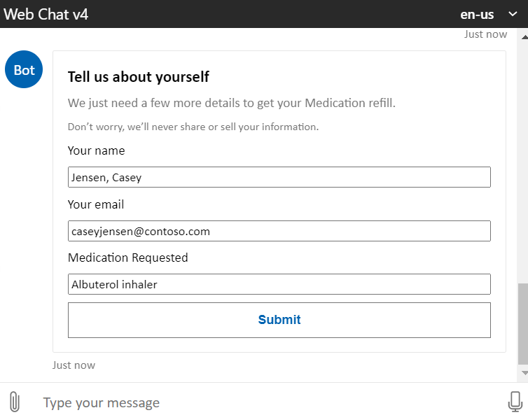

1. **Fill in information** for the request and click **Submit** to see the confirmation text.

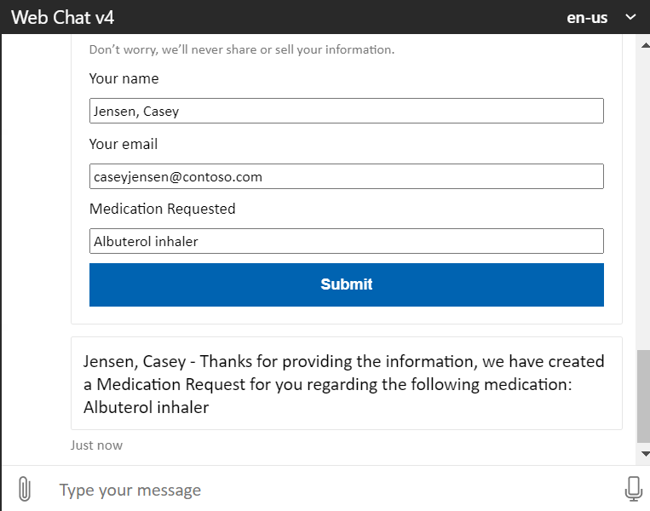

Step 6: Invoke Live Agent Action

1. Add a **Statement** element to the canvas.



1. Enter **Display Text**: Please wait, I am transferring your request to a live agent for further assistance.
2. Rename the statement to **Live Chat**.

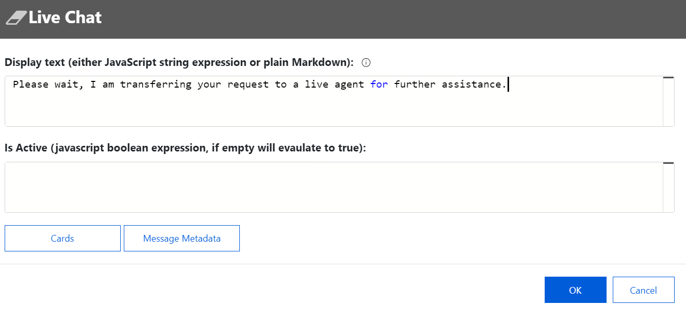

1. Click **OK** to return to the designer page.
2. **Connect** the **No** decision of the **IsMedRefill** branch to the **Live Chat** statement.

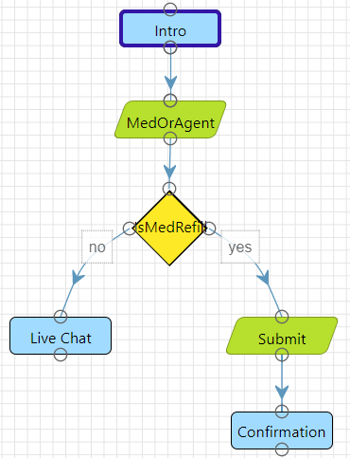

Step 7: Add Action to Invoke Escalation

1. Add an **Action** element to the canvas, used to trigger an escalation to Omnichannel Live Agent

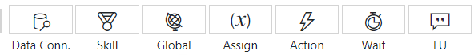

1. Add the following code in the action, which will trigger the Live agent chat:

session.sendChannelData('Escalating...', {

"tags": JSON.stringify({type: "Escalate", context: {"EscalateToAgent": 1}})

});

1. Name the action **Escalate**. Click **OK** to return to the designer page.

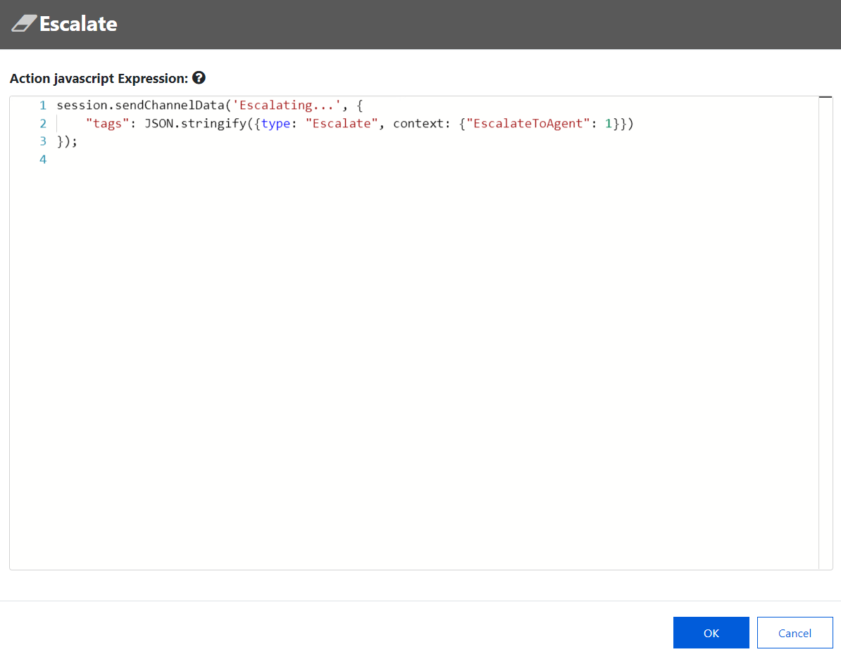

1. **Connect** the **Live Chat** to the new **EscalateToAgent** action. You completed the final connection!

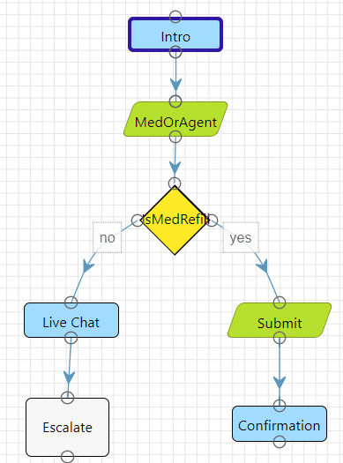

1. **Save** and **run** your scenario to see the full scenario output.
2. Test all logical paths. Selecting Live Agent in the authored card should show the escalation action.

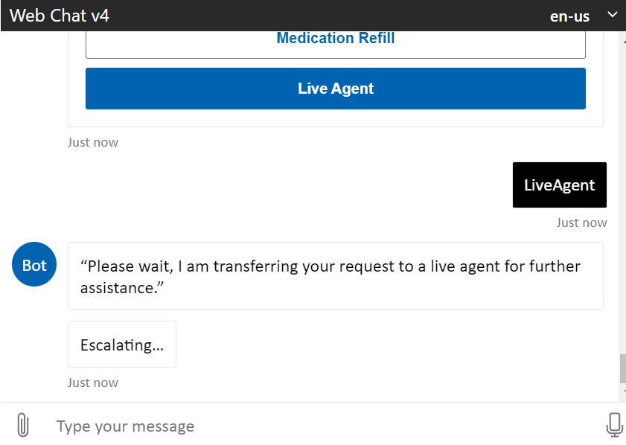

1. **Exit** the MCH_PatientSerivce scenario editor.

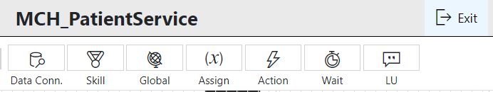

Task 2: Create MCH_PatientServiceWelcome Scenario

In this task, you will create another bot scenario called **MCH_PatientServiceWelcome** to invoke the **MCH_PatientService** scenario.

1. On the Azure Health Bot scenarios page, select **+New** to create another new scenario

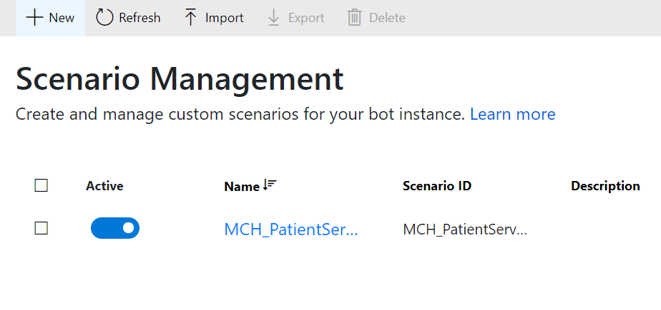

1. Provide the following details for the new scenario:
   1. **Name**: MCH_PatientServiceWelcome
   2. **Scenario ID**: MCH_PatientServiceWelcome
   3. Select **Create**.

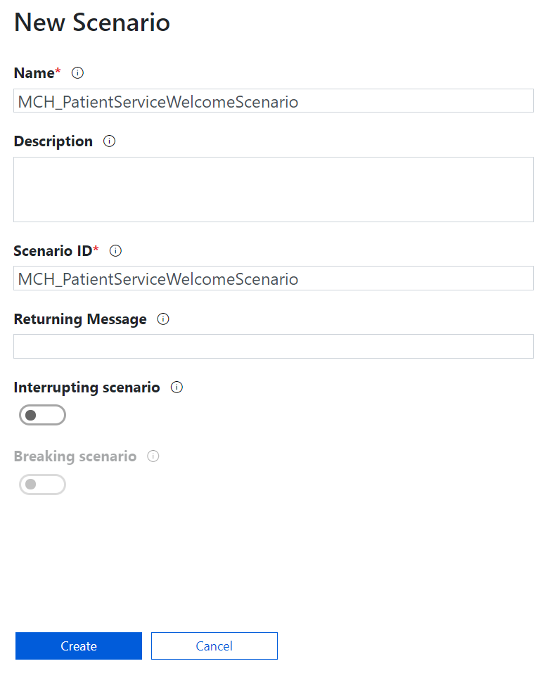

1. On the scenario editor designer, add a **Statement** element.



1. Rename the statement **Welcome**. Do not add any Display text as we will show it in the card instead.

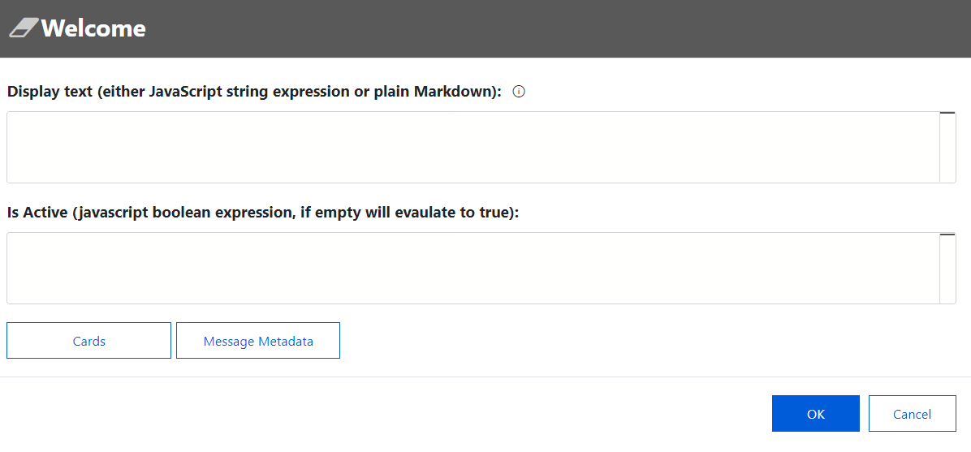

1. Select **Cards.**

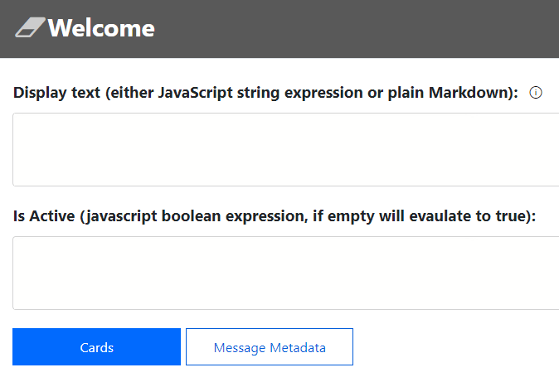

1. Select **Add Card**.  
   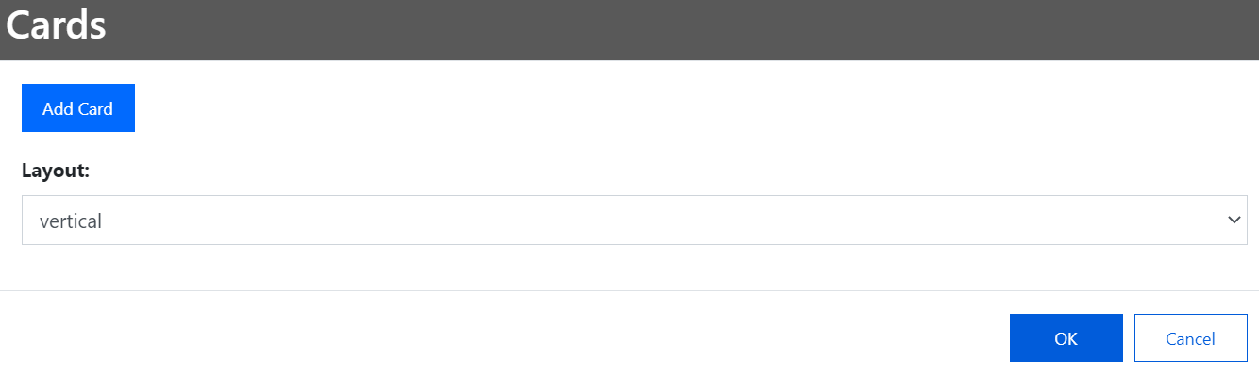
2. Choose **HeroCard.** Add **Title**: Welcome to Lamna Healthcare Patient Service Portal

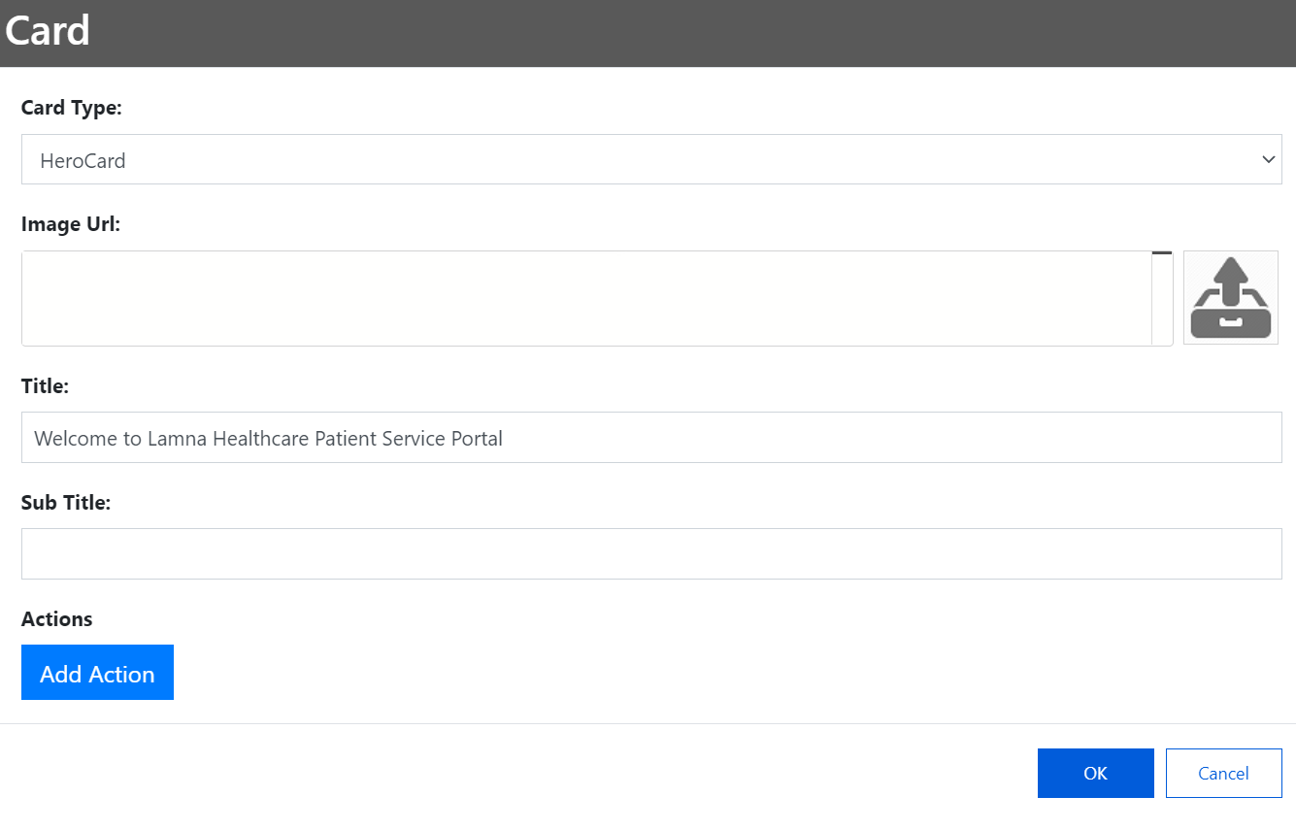

1. Select **Add Action** and provide the following details:
   1. **Action type**: imBack
   2. **Action value**: "begin MCH_PatientService"
   3. **Action title**: "Lamna Healthcare Support"

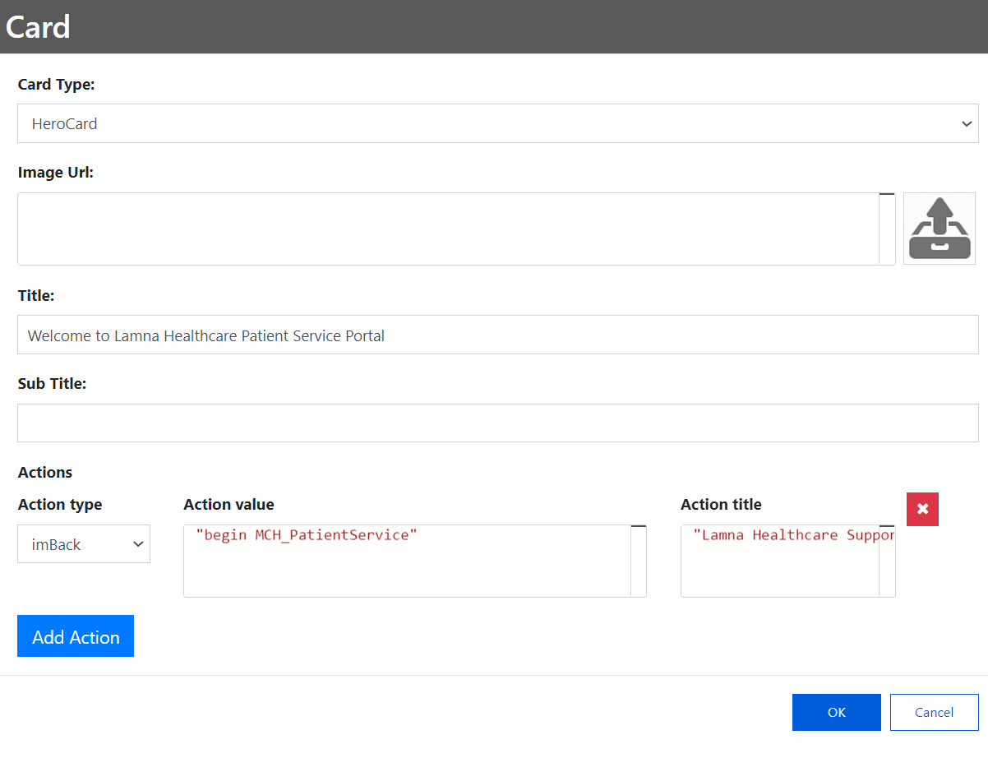

1. Click **OK** and view your completed scenario. This will be used to kick off the conversation and allow the other MCH_PatientService scenario to be invoked through the authored card.

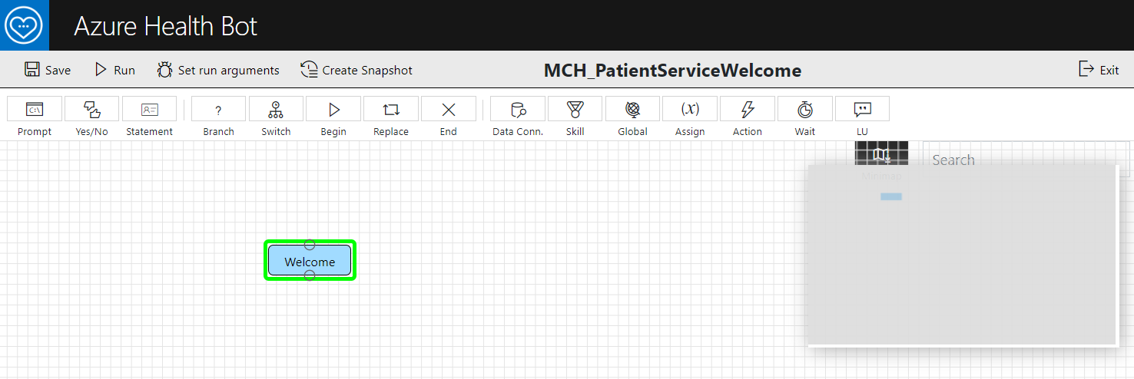

1. **Save** and **run** to test your bot scenario **MCH_PatientServiceWelcome** scenario in the Web Chat.

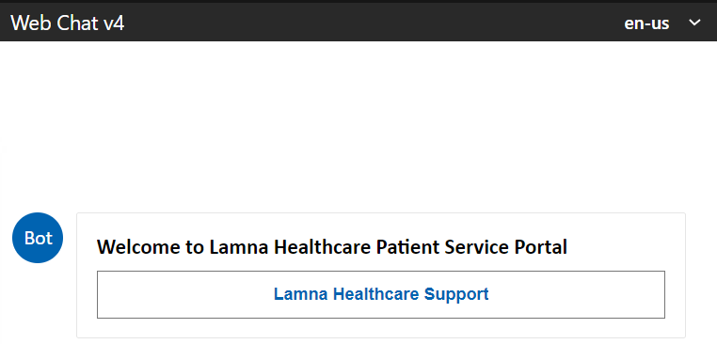

1. **Exit** the scenario designer.

Task 3: Configure Welcome Scenario as Automatic

In this task, we will set the MCH_PatientServiceWelcome to be the “Automatic Welcome Scenario” in settings. This will always trigger the welcome scenario when a user starts a conversion with the **Azure** **Health Bot**.

1. Navigate to **Configuration** > **Conversation**

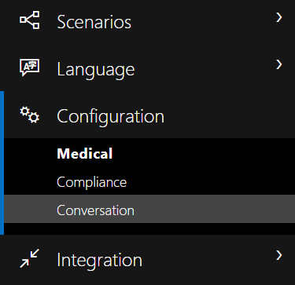

1. In the **Interactions** tab, scroll down to the **Automatic Welcome** section.

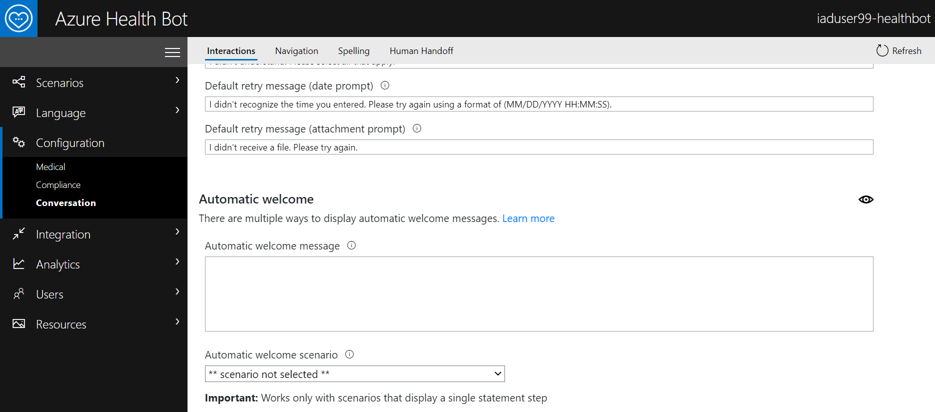

1. In the **Automatic welcome scenario** dropdown, select the **MCH_ PatientServiceWelcome** scenario.

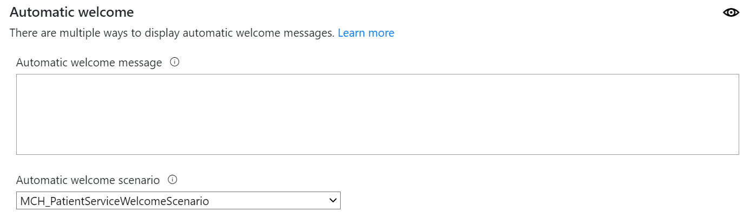

Task 4: Test Health Bot Escalation from Power Apps Portal to Dynamics 365 Omnichannel

1. Navigate to Power Apps and click to open **Lamna Healthcare Patient Portal**.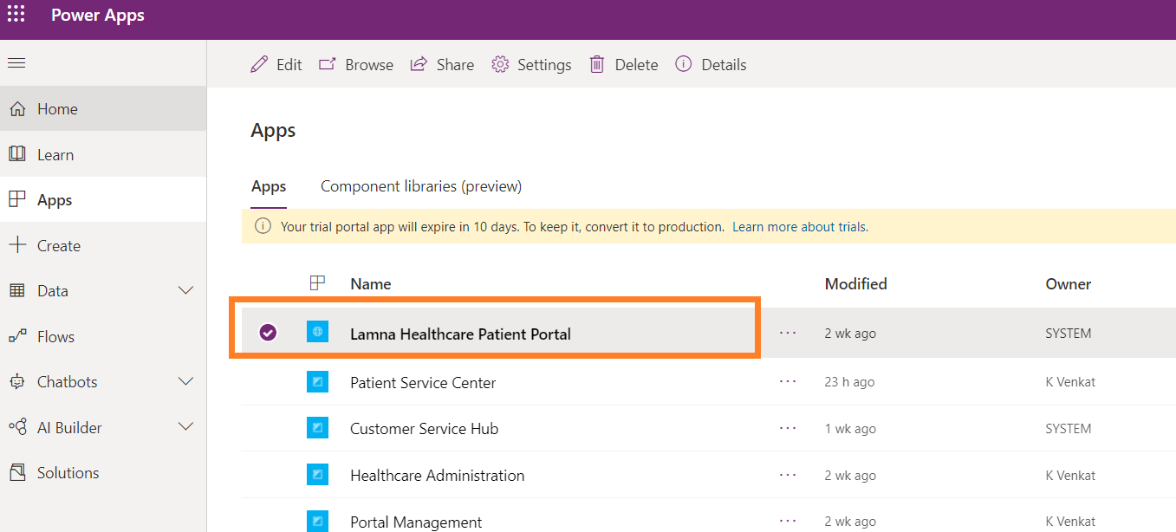
2. You should see the Health Bot “Let’s Chat” button in the lower right-hand corner of the screen. This means the chat widget was successfully embedded into the Customer Self-service portal. 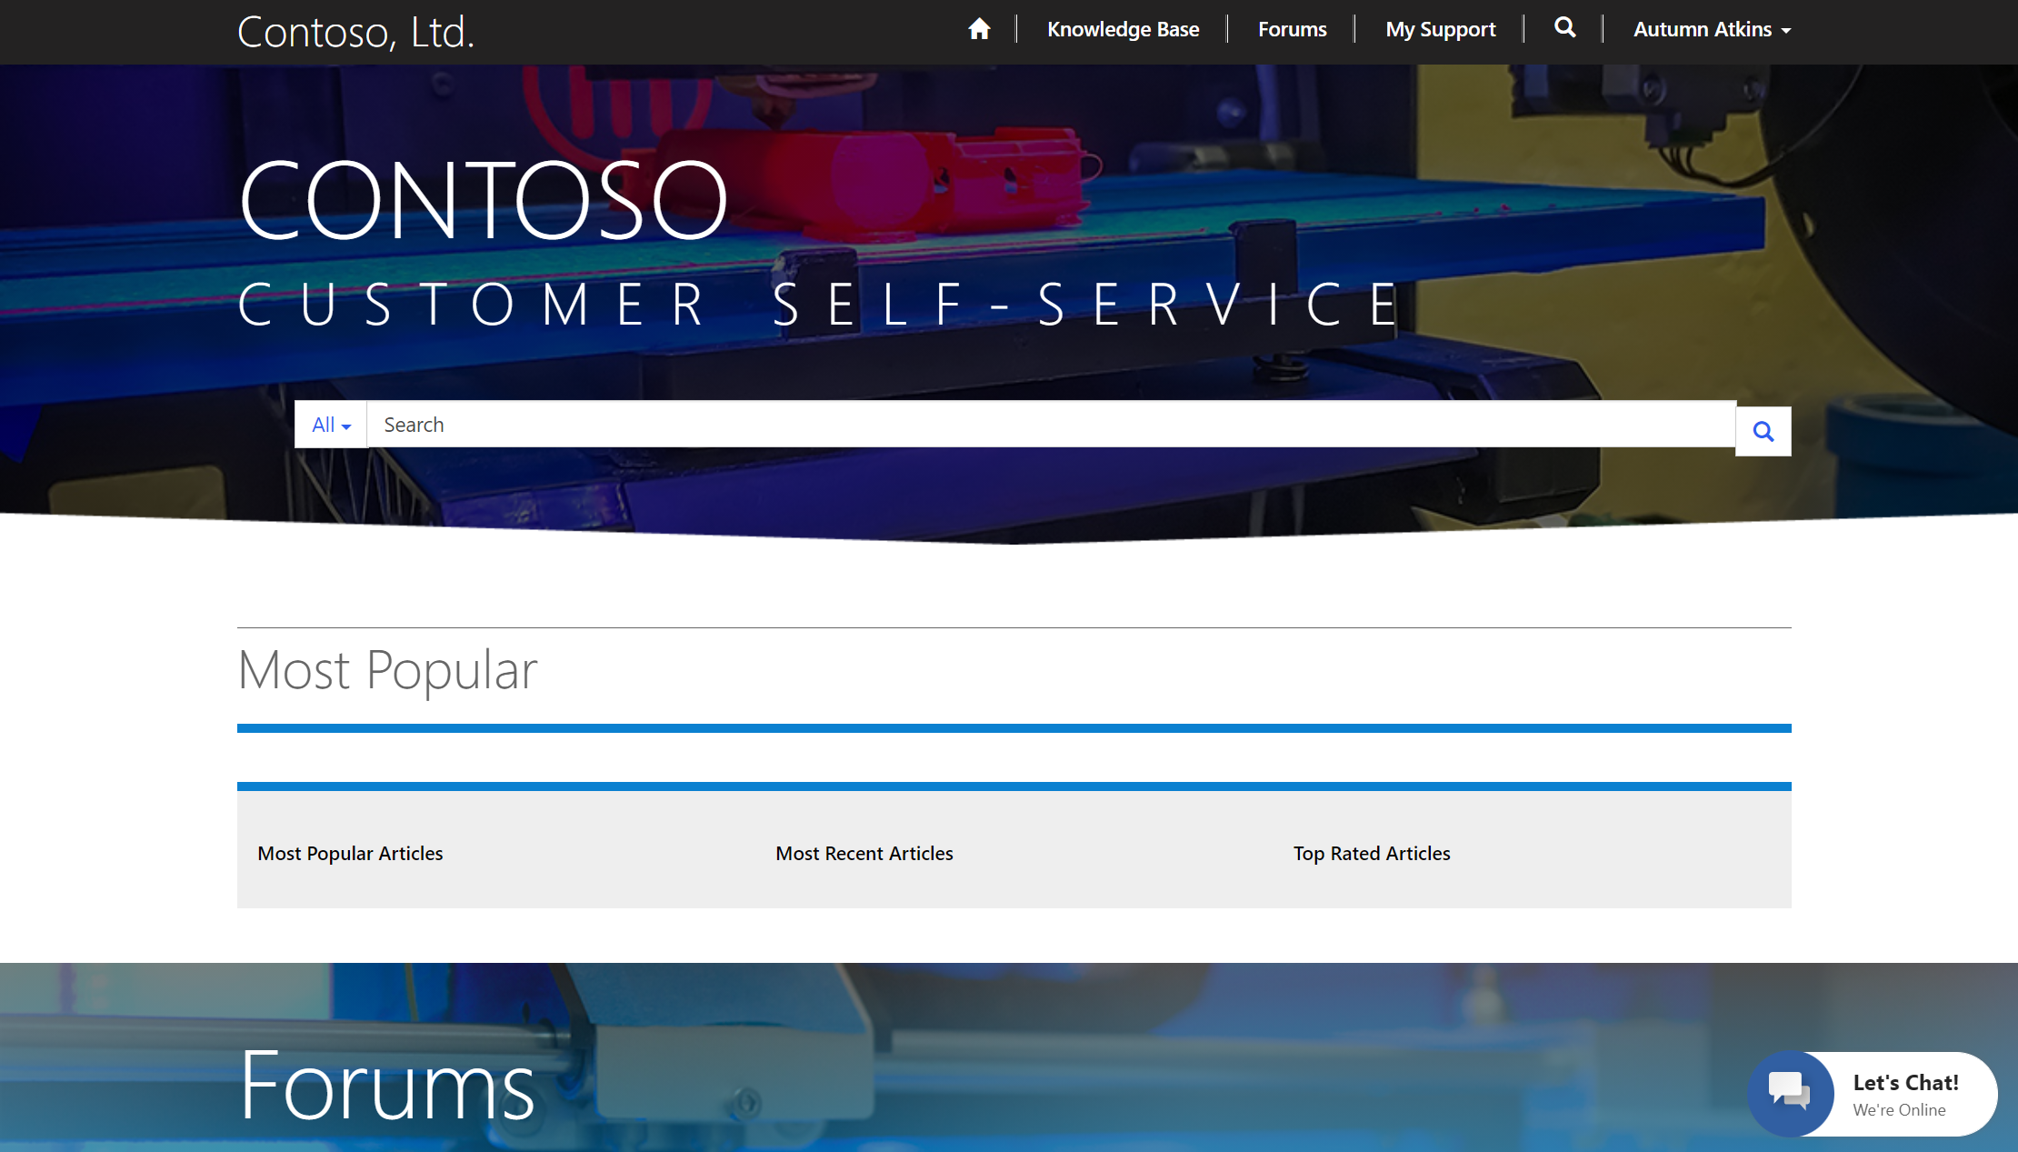
3. When you the click chat widget, bot will trigger a welcome scenario message we created and set as the default welcome message (**MCH_PatientServiceWelcome)**.

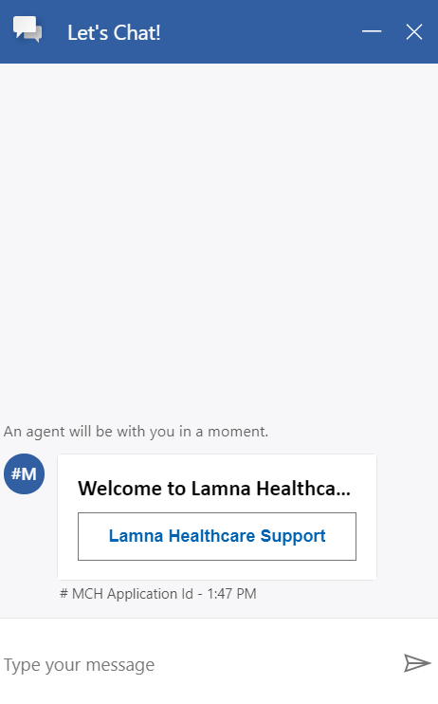

1. Navigate back to Power Apps and open **Customer Service Workspace.**

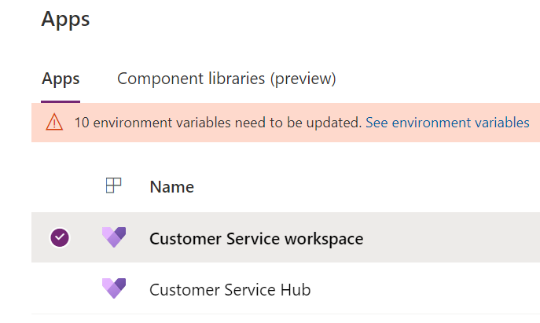

**Note**: Omnichannel for Customer Chat Widget will work only when you see the presence status is enabled. There should be a splash loading screen that goes through multiple steps and then displays the status indicator as available once loaded. (Status is enabled when green with checkmark in circle**)**

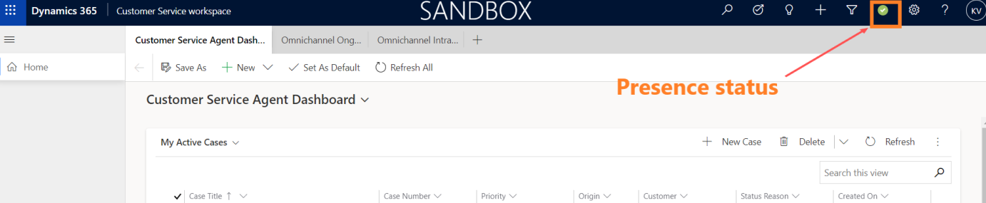

Splash screen: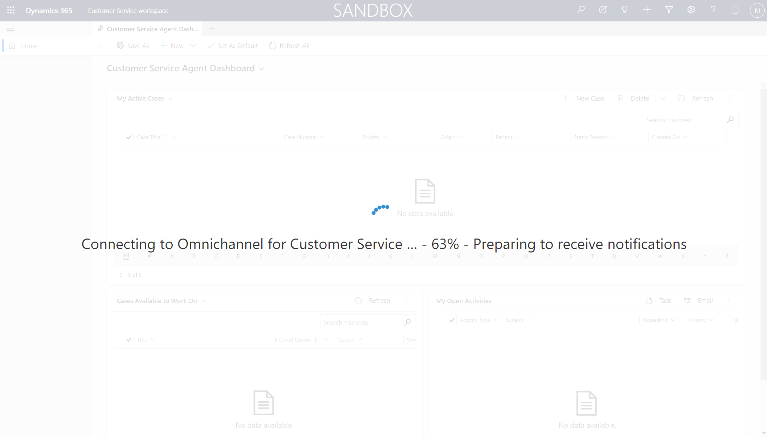

1. In the Health Bot in Lamna Healthcare Patient Portal, click **Lamna Healthcare Support** button, then the **Live Agent** button to witness the escalation into Omnichannel to chat with a live agent (your user!) 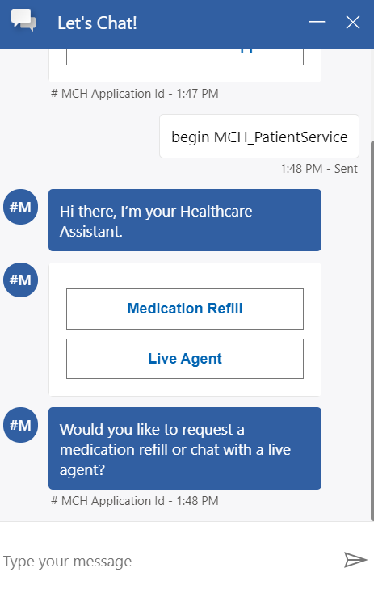 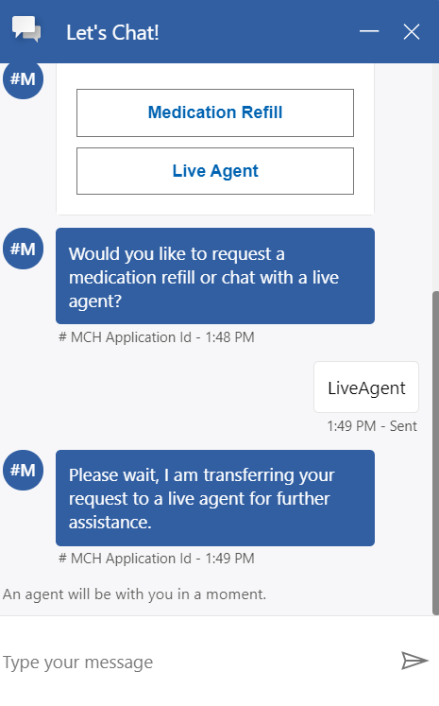
2. Navigating back to Omnichannel for Customer Service, your user as the **Live Agent** should receive an incoming notification with **Accept/Reject** options for that chat.
3. Click **Accept** to connect and chat with customer (In this case chat with the **patient**).

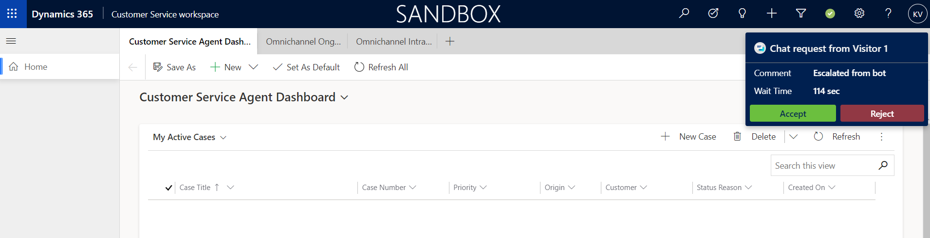

1. As soon as Live Chat Agent accepts the incoming chat notification, Omnichannel for Customer Service has opened a **Live Chat Widget** and Agent would be able to see the entire bot conversation with user and continue the chat conversation with user for further assistance.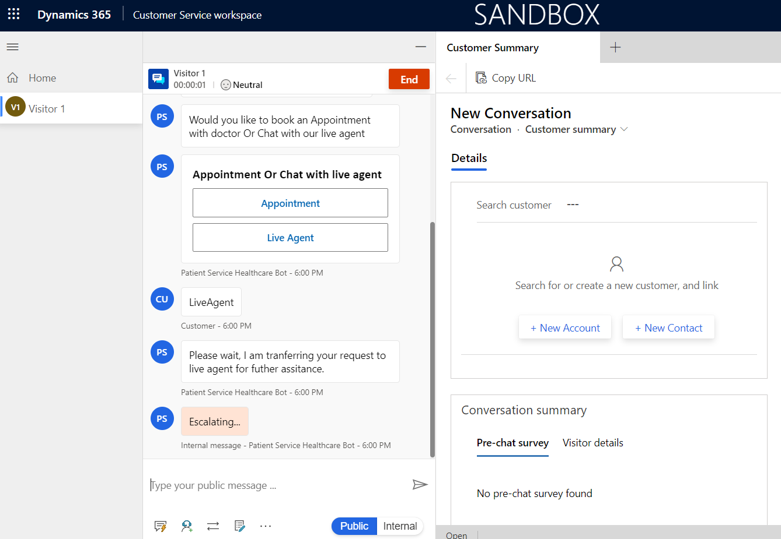

**Congratulations!** You have successfully extended the Azure Health Bot with custom scenarios and tested the end-to-end escalation scenario from a patient using the Azure Health Bot in Power Apps Portals to chatting with a Live Agent in Omnichannel for Customer Service.

Summary

**Nice work!** You have completed **Lab 04 – Azure Health Bot**.

In this lab, you learned how to do the following:

* Set up Azure Health Bot
* Configure Dynamics 365 Customer Service Omnichannel Live Chat
* Embed Azure Health Bot in a Power Apps Portal
* Extend Azure Health Bot with custom scenarios